Annex 3.
Form of opening (renewal) for Project /
Sub-project of LRIP

APPROVED
JINR DIRECTOR
/
" " ___ 202_ г.

SCIENTIFIC AND TECHNICAL REASONING FOR THE OPENING / RENEWAL
OF PROJECT/SUB-PROJECT OF LARGE RESEARCH INFRASTRUCTURE PROJECT
IN RESEARCH AREA WITHIN THE TOPICAL PLAN FOR JINR RESEARCH

1. General information on the project/subproject of the large research infrastructure project

  - Theme code / (for renewable themes) - the theme code includes the opening date, the closing date is not given, as it is determined by the completion dates of the projects in the topic.
02-1-1096-2010 Study of rare charged kaon decays and Search for dark sector in experiments at the CERN SPS
  - Project/sub-project of a MIP code (for renewed themes) 02-1-1096-2-2010/2026

  - Laboratory of High Energy Physics, LHEP

  - Scientific field Elementary particle physics and relativistic nuclear physics, HEP & PP

  - The name of the Project NA64 experiment

1.6 Project Leader(s) V.A.Matveev

  - Project Deputy Leader(s) (scientific supervisor of the project/sub-project of the LRIP)
D.V.Peshekhonov

2 Scientific rationale and organisational structure
2.1 Annotation
Despite the intensive searches at the LHC and in non-accelerator experiments Dark Matter (DM) is still a great puzzle. Though stringent constraints obtained on DM coupling to Standard Model (SM) particles ruled out many DM models, little is known about the origin and dynamics of the dark sector itself. The main difficulty so far is that the only established way to probe DM is through its gravitational interaction. An exciting possibility is that in addition to gravity, a new force between the dark sector and visible matter transmitted by a new vector boson A' (dark photon) might exist. Such A' could have a mass mA' < 1 GeV - associated with a spontaneously broken gauged U(1)D symmetry- and couple to the SM through
kinetic mixing with the ordinary photon, parametrized by the mixing strength ε<< 1. This has motivated a worldwide theoretical and experimental effort towards searches for dark forces and other portals between the visible and dark sectors, shifting the strategy from the high energy to the high intensity frontier.
An additional motivation for the existence of the A' has been provided by hints of the astrophysical signals of dark matter, as well as the 3.6 σ deviation from the SM prediction of the muon anomalous magnetic moment (g-2)μ. Possible explanation of the (g-2)μ anomaly is related to the existence of a new light ( with a mass m_{Z}' < 1 GeV) vector boson which couples very weakly with the muon with α_{Z'} ~ O(10⁻⁸).
The NA64 experiment is a fixed-target experiment at the CERN SPS designed as a hermetic detector to search for Dark Sector physics in missing energy events from electron/positron, muon and hadrons scattering off nuclei.

2.2 Scientific justification (purpose, relevance and scientific novelty, methods and approaches, methodologies, expected results, risks)

The proposal (P348) to search for Dark Sectors at the CERN Super Proton Synchrotron (SPS) [1] was positively received by the SPS committee (SPSC) in April 2014. The test beam run was granted in 2015 for a feasibility study, and the proposal was finally approved as the 64th CERN experiment in the North Area (NA64) in March 2016. NA64 is designed as a hermetic general-purpose detector to search for Dark Sector (DS) physics in missing energy events from electron/positron, hadron, and muon scattering off nuclei. The main focus of the NA64 is Light thermal Dark Matter (LDM) interacting with the Standard Model (SM) via vector (or other) portal, such e.g. as dark photons (A′) and a variety of New Physics scenarios. The experiment, in electron mode (NA64e), employs the optimized 100 GeV electron beam from the H4 beam-line at the North Area. The beam was designed to transport the electrons with the maximal intensity up to a few 10⁷ per SPS spill of 4.8 s in the momentum range between 50 and 150 GeV/c. The hadron contamination in the electron beam was measured to be at a level of π/e⁻ < 2% and K/e⁻ < 0.3%. The NA64 experiment run from 2016 until 2018, and after the CERN long shutdown (LS2) in 2021, it resumed data taking in a new permanent location at H4 beamline CERN prepared for us. Despite the experiment being quite new, very interesting results were rapidly achieved [2–4]. In this contribution, we review the main results accomplished so far subdividing those into the A′ decay modes being explored.
Invisible mode: NA64 pioneered the active beam dump technique combined with the missing energy measurement to search for invisible decays of massive A′, produced in the ECAL target (the electromagnetic (em) calorimeter) by the dark Bremsstrahlung reaction e−Z → e−ZA′, where electrons scatter off a nucleus of charge Z. After its production, the A′ would promptly decay into a pair of LDM candidate particles, A′ → χχ, which would escape the setup undetected leaving missing energy as a signature. For this reason, we call these searches invisible. The parameter space characterized by mixing strengths 10⁻⁶ < ε < 10⁻³ and masses m_{A′} in the sub-GeV range is the NA64 physics scope: a region where the DM origin can be explained as a thermal freeze-out relic. Missing energy experiments, such as NA64, require precise knowledge of the incoming beam (momentum and particle ID) and an accurate measurement of the deposited energy from the incoming beam’s interaction. A signal event is defined as a single electromagnetic shower in the ECAL with an energy E_{ECAL} below the given threshold1 accompanied by a significant missing energy E_{miss} = E_{A′} = E_{initial} − E_{ECAL}. The occurrence of the A′ production is inferred in case these events show an excess above those expected from backgrounds. In Fig. 1, we present a sketch of the setup and a summary of the NA64 working principle. The signal yield for an active beam approach is proportional to ε², thus, enhancing the sensitivity for NA64 with respect to the yield ∝ α_{D}ε⁴ in traditional beam-dump approach where the A′ decay is measured in a detector further away from its production point in the dump.
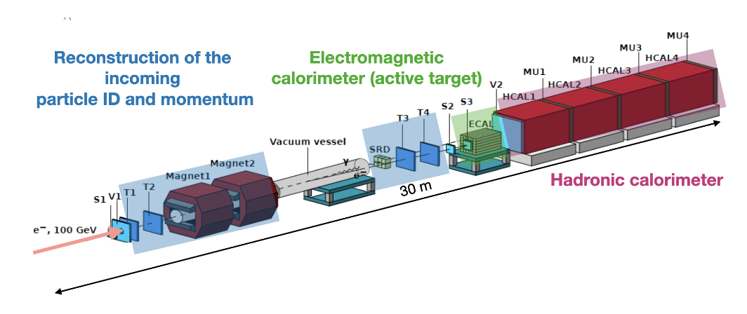

Figure 1: Na64 setup and working principle for the search of dark photons through missing ebergy in the active target (ECAL). Section up to the ECAL responces on the reconstruction of the incoming particle ID and momentum.

The main results achieved so far in the invisible electron mode are:
In 2016-2018 data taking runs: 3 · 10¹¹ electrons on target (EOT) have been collected. No signal-like event was detected. However, the results of the combined analysis, illustrated in Fig. 2, set the most stringent limit for LDM below 0.1 GeV for the canonical benchmark parameters α_{D} = 0.1 and m_{A′} = 3m_{χ}, thus, NA64 became the leading beam-dump experiment in this region. Besides this, obtained data excludes most of the favored region of parameter space compatible with the muon g − 2 anomaly depicted as a band in the left plot of Fig.2. After our results were published, BABAR completely closed the remaining region of parameter space which could provide an explanation as the Dark photon contributing to the g-2 muon [5]. These results were selected as PRL editor’s suggestion [6].
In addition to the Bremsstrahlung reaction, the resonant A′ production channel through the e⁻ annihilation with the positrons present in the electromagnetic shower has also been considered. The 90% C.L. exclusion limits from the combined analysis are shown in Fig. 2. The inclusion of the resonant process in the data analysis allows enhancing the NA64 sensitivity for a given dark photon mass resulting in a peak around 200 MeV. The addition of this process improves the NA64 sensitivity in the high mass region, where the Dark photons yield is suppressed due to the 1/m²_{A′} dependency of the Bremsstrahlung cross-section (see [6]). Using positrons as a primary beam instead of electrons would increase by another order of magnitude the sensitivity of NA64 at a given mass depending on the beam energy. By scanning the positron beam energy the mass range probed by this mode can be further expanded. The drawback is that one has to deal with about an order of magnitude more hadron contamination in the beam since the secondary particles are created by the primary 400 GeV SPS protons and thus positively charged hadrons are more abundant than their negative counterpart. To study the impact of the increased hadron contamination and the possible resulting background, a first test beam with 100 GeV positron was taken during the 2022 run (see below). Electron/positron beam-dump experiments allow exploring alternative scenarios to the dark photon hypothesis. NA64 has already proven its potential to search for light-scalar and pseudo-scalar axion-like particles (ALPs) produced through the Primakoff reaction [7]. The current NA64 coverage in these searches closes part of the gap between beam-dump and LEP bounds and it is shown in the right plot of Fig. 3. A search for a generic X-boson coupling to electrons could also be performed. We were positively surprised that the NA64 sensitivity was an order of magnitude more stringent than precision experiments [8]. However, one should note that in NA64 we assume the X-boson to decay invisibly while the electron g-2 [9] and the fine structure measurements [10, 11] are
model-independent.
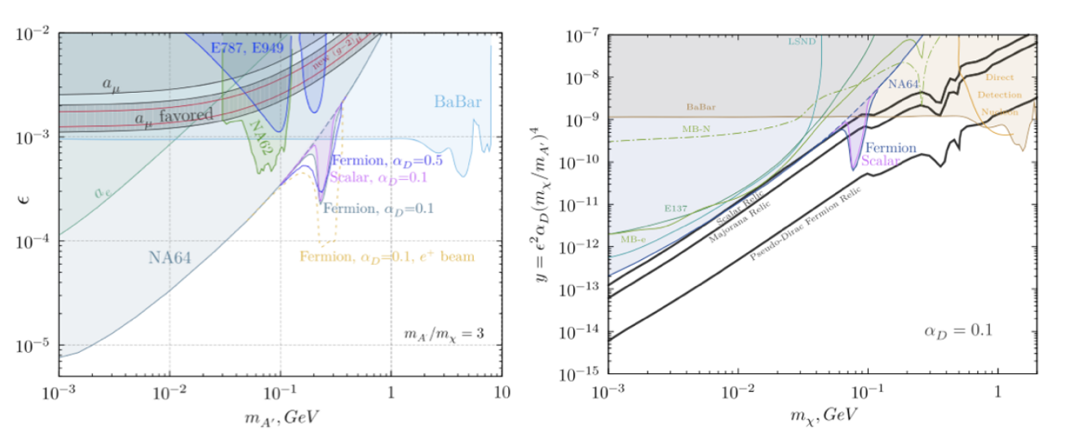
Figure 2: Current status of NA64 experiment 90% C.L. exclusion limits on A’ invisible decays including both the Bremsstrahlung and the resonant A’ production channeks (left) LDM searches (right) [6]

Visible mode: The method for the search of A′ → e⁺e⁻ (X → e⁺e⁻) decays is described in [1, 12]. In this case, the setup is slightly modified to include an additional compact calorimeter upstream with respect to the ECAL. If the A′ exists, due to the A′(X) − e⁻ coupling it would occasionally be produced by a shower electron (or positron) in its scattering off a nucleus in the dump: e⁻ + Z → e⁻ + Z + A′(X); A′(X) → e⁺e⁻. Since the A′ is penetrating, it would escape the beam dump and subsequently decay into an e⁺e⁻ pair in a downstream set of detectors. The pair energy would be equal to the energy missing from the target. Thus, the signature of the A′(X) → e⁺e⁻ decay is an event with two em-like showers in the detector: one shower in the dump, and another one in the ECAL, located downstream
in this case, with the sum energy being equal to the beam energy.
In 2017-2018 runs: ~ 10¹¹ EOT were accumulated. No candidates were found in the signal box. These results set the first limits on the X − e⁻ coupling in the range 1.2 × 10⁻⁴ < ε_{e} < 6.8 × 10⁻⁴ excluding part of the parameter space suggested by the so called Beryllium anomaly [13] which could be explained by a new X boson with a mass around 17 MeV (named X17) [14]. In addition, new bounds are set on the mixing strength of photons with dark photons (A′) from non-observation of the decay A′ → e⁺e⁻ of the Bremsstrahlung A′ with a mass < 23 MeV. The corresponding paper was highlighted as an editor’s suggestion in Phys. Rev. Lett. 5 [4] and in Phys. Rev. D Rapid [15]. Recently, these searches have been extended also to a pseudo-scalar particle decaying visibly into a lepton pair and the result has been published in Phys. Rev. D [16].

To completely cover the remaining region of parameter space a new shorter optimized WCAL and a new spectrometer with the possibility to reconstruct the X17 invariant mass should be used as proposed in [17]. Everything has been prepared and is ready for installation. However, since it cannot run in parallel with the invisible mode setup we decided to postpone this search. About 30 days of beam-time would be required to solidly probe the remaining X17parameter space, therefore if the results from PADME currently taking data [18], would confirm this anomaly we would be able to cross-check this in the 2024 run.
Semi-visible mode: Alternative extended scenarios envisioning two DM species split in mass could result in a signature that is a combination of the two signatures described above. A very intriguing feature of this channel is related to the possibility to recover both the DM thermal freeze-out and the (g − 2)_{μ} anomaly explanations, by evading the existing experimental constraints on pure visible and invisible modes [19]. These types of models are known as inelastic DM and we refer to their signatures as a semi-visible channel. An analysis based on a recast of the results from the combined 2016-2018 data [20] (see the left plot of Fig. 3) has already demonstrated the potential of NA64 to study these models.
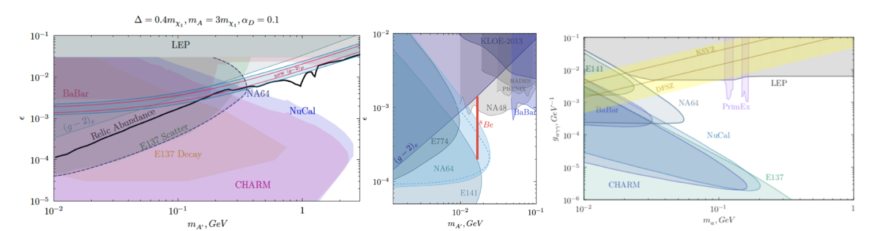
Figure 3:Current status of the NA64 experiment 90% C.L. exclusion limits on semi-visible A’ decays [20] (left) visible decays (center) [15] and NA64 coverage in ALPs searches [21] (right)

Current status and prospects of NA64
The very dense NA64 program restarted after LS2 in August 2021 with the installation of the setup in the new permanent experimental area in the H4 SPS beam line. The setup was ready for the 6 weeks beam-time in 2021 and took data during 10 weeks in 2022. The goal is to continue our DS exploration until LS3 and collect around 5 · 10¹² EOT in order to probe the parameter space for light DM models suggested by the observed relic density and other interesting New Physics scenarios. Depending on the results of PADME, in 2024 the upgraded visible setup could be installed to probe the full parameter space of the hypothetical X17 boson.
Combining the 2021 data with the one collected before LS2 (total statistic of 3.2 · 10¹¹ electrons on target), weperformed a search for a new Z′ gauge boson associated with (un)broken B-L symmetry [22]. No signal events were found, thus, new constraints on the Z′-e coupling strength were set. For the mass range 0.3 < m_{Z′} < 100 MeV, these limits are more stringent than those obtained from the neutrino-electron scattering data (see Fig. 4. The data also indicate that NA64 is background free at a level of 1 × 10¹². Another possibility that is currently under investigation is based on the existence of a light Z′ boson resulting from gauging the difference of the lepton number between the muon and tau flavor. This hypothetical boson can couple via QED vertex corrections to the electron and its existence could explain both the muon g-2 anomaly and the DM relic composition. Moreover, this Z′ can be produced again through the dark Bremsstrahlung process, e⁻N → e⁻N Z′, but also via the resonant annihilation with secondary positrons from the shower. With the 2016-2018 statistics, NA64 was able to probe in this scenario the region suggested by the (g − 2)_{μ} anomaly up to m_{Z′} ∼ 1 MeV [23]. Such a light Z′ can additionally couple directly to muons and its search is therefore also one of the physics goals of NA64μ, the NA64 extension using a high energetic muon beam [24, 25].
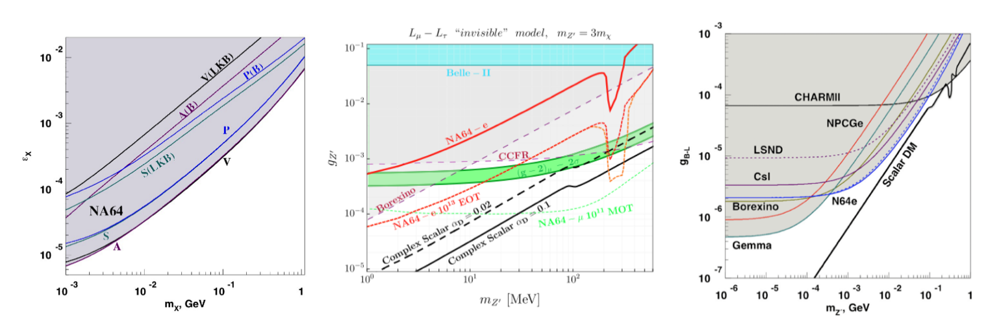
Figure 4: Left: NA64 limits for a generic X boson, for the scalar (S), vector (V), pseudo-scalar (P) and asial vector (A) cases [8]. Center: NA64e exclusion limit for the L _{μ} – L_{τ} (red line) obtained with 2016-2018 statistics for models where Z’ can decay to DM particles [23]. The red dashed curves present the sensitivity projections for a future NA64e runs with an elelctron (positron) beam, for a total of 10¹³ EOT, while the green dashes curve is the sensivity projection of NA64_{μ.} Right: NA64 exclusion limits for a new B-L Z’ boson [22].

The NA64μ program started in 2021 with two pilot runs at the M2 beam-line using the unique CERN 160 GeV/c muon beam. This will probe DS in a complementary way to the H4 measurements with electrons and will address the g-2 muon anomaly [25]. The main difference between the experimental technique used in NA64μ compared to NA64e is that in this case one has to rely solely on momentum reconstruction to measure the missing energy carried away from a possible Z′ or A′ decay. This makes NA64μ much more challenging than NA64e where one employs calorimeters for this purpose. During the pilot runs in 2021 and 2022, a total of 4 · 10¹⁰ MOT were collected. The analysis is still ongoing but the preliminary results already hint to the fact that an additional spectrometer should be added upstream the ECAL since an accurate determination of the incoming momentum is crucial for the experiment. This will be tested in 2023 and the first physics runs are expected for 2024-2025. It is worth mentioning, that for the new-physics process simulations and for detailed comparison between data and Monte Carlo, a new GEANT4 based package called DMG4 [26] was developed by NA64 members, which has been well accepted by the community, see, e.g [27].

Outlook and conclusions
NA64 just reached a major milestone of accumulating ∼ 10¹² EOT which allows one to start probing very interesting LDM benchmark models. The analysis is ongoing and with the increased statistics we expect to improve the sensitivity also of our searches for ALPs, L_{μ}-L_{τ} and B-L Z′ bosons, inelastic DM and generic X bosons. The plan until LS3 is to accumulate as many as possible electrons on target (up to 5·10¹²) and if the background will be under control also use the positron mode to enhance the sensitivity in the higher A′ mass region. To study the impact of the larger hadron contamination when running with positrons compared to electrons, in the 2022 run 2 days were used to collect ∼ 10¹⁰ positrons on target (the analysis is ongoing).
NA64 also started its program at the M2 beam-line providing unique high intensity 160 GeV muons to explore dark sectors weakly coupled to muons. The results of the pilot runs show that with an optimized setup, one could collect > 10¹¹ MOT before LS3 in order to check if an L_{μ}-L_{τ} Z′ boson is the explanation of the g-2 muon anomaly and complement the searches with electrons (see [28]). After LS3 the experiment would then continue data taking to accumulate ∼ 10¹³ MOT to explore the A′ higher mass region and μ → τ and μ → e LFV processes [29].
In the 2022 beam-time, we also dedicated 1 day of data taking to accumulate ∼ 2 × 10⁹ pions on target in order to understand the potential of NA64 to explore dark sectors coupled predominantly to quarks using the missing energy technique [30, 31]. This will be further investigated and, if the feasibility would be demonstrated, a dedicated search will be performed after LS3.
To conclude the exploration of the NA64 physics potential has just begun. Our proposed searches with leptonic and hadronic beams provide unique sensitivities highly complementary to similar projects.

Risks:
- the possible overall reduction in the beam time for the experiments at CERN;
- JINR and RF institution are strongly involved in the experiment covering almost all main setup subsystems. JINR team in particular has hardware responsibility on the straw tube tracking detectors and deeply involved in the support of the experiment DAQ. Exist the risk in the fulfilling of JINR and RF institutions obligations in case of some restrictions on the collaboration.

References
[1] S. Andreas, P. Crivelli, et al. Proposal for an Experiment to Search for Light Dark Matter at the SPS. 2013.
[2] D. Banerjee, P. Crivelli, et al. Search for invisible decays of sub-GeV dark photons in missing-energy events at the CERN SPS. Phys. Rev. Lett., 118(1):011802, 2017.
[3] D. Banerjee, P. Crivelli, et al. Search for vector mediator of Dark Matter production in invisible decay mode. Phys. Rev., D97(7):072002, 2018.
[4] D. Banerjee, P. Crivelli, et al. Search for a Hypothetical 16.7 MeV Gauge Boson and Dark Photons in the NA64 Experiment at CERN. Phys. Rev. Lett., 120(23):231802, 2018.
[5] J. P. Lees et al. Search for Invisible Decays of a Dark Photon Produced in e+e− Collisions at BaBar. Phys. Rev. Lett., 119(13):131804, 2017.
[6] D. Banerjee et al. Dark matter search in missing energy events with NA64. Phys. Rev. Lett., 123(12):121801, 2019.
[7] D. Banerjee et al. Search for Axionlike and Scalar Particles with the NA64 Experiment. Phys. Rev. Lett.,125(8):081801, 2020.
[8] Yu. M. Andreev et al. Constraints on New Physics in Electron g − 2 from a Search for Invisible Decays of aScalar, Pseudoscalar, Vector, and Axial Vector. Phys. Rev. Lett., 126(21):211802, 2021.
[9] X. Fan, T. G. Myers, B. A. D. Sukra, and G. Gabrielse. Measurement of the Electron Magnetic Moment. 9 2022.
[10] Richard H. Parker, Chenghui Yu, Weicheng Zhong, Brian Estey, and Holger M ̈uller. Measurement of the fine-structure constant as a test of the Standard Model. Science, 360:191, 2018.
[11] L ́eo Morel, Zhibin Yao, Pierre Clad ́e, and Sa ̈ıda Guellati-Kh ́elifa. Determination of the fine-structure constant with an accuracy of 81 parts per trillion. Nature, 588(7836):61–65, 2020.
[12] S. N. Gninenko. Search for MeV dark photons in a light-shining-through-walls experiment at CERN. Phys. Rev., D89(7):075008, 2014.
[13] A. J. Krasznahorkay et al. Observation of Anomalous Internal Pair Creation in Be8 : A Possible Indication of a Light, Neutral Boson. Phys. Rev. Lett., 116(4):042501, 2016.
[14] Jonathan L. Feng, Bartosz Fornal, Iftah Galon, Susan Gardner, Jordan Smolinsky, Tim M. P. Tait, and Philip Tanedo. Particle physics models for the 17 MeV anomaly in beryllium nuclear decays. Phys. Rev., D95(3):035017, 2017.
[15] D. Banerjee et al. Improved limits on a hypothetical X(16.7) boson and a dark photon decaying into e+e− pairs. 2019.
[16] Yu. M. Andreev et al. Search for pseudoscalar bosons decaying into e+e− pairs in the NA64 experiment at the CERN SPS. Phys. Rev. D, 104(11):L111102, 2021.
[17] E. Depero et al. Hunting down the X17 boson at the CERN SPS. Eur. Phys. J. C, 80(12):1159, 2020.
[18] Luc Darm ́e, Marco Mancini, Enrico Nardi, and Mauro Raggi. Resonant search for the X17 boson at PADME. 9 2022.
[19] Gopolang Mohlabeng. Revisiting the dark photon explanation of the muon anomalous magnetic moment. Phys. Rev. D, 99:115001, Jun 2019.
[20] C. Cazzaniga et al. Probing the explanation of the muon (g-2) anomaly and thermal light dark matter with the semi-visible dark photon channel. Eur. Phys. J. C, 81(10):959, 2021.
[21] Sergei Gninenko. NA64 Status Report 2018. Technical Report CERN-SPSC-2018-015. SPSC-SR-231, CERN, Geneva, May 2018.
[22] Yu. M. Andreev et al. Search for a New B-L Z’ Gauge Boson with the NA64 Experiment at CERN. Phys. Rev. Lett., 129(16):161801, 2022.
[23] Yu. M. Andreev et al. Search for a light Z’ in the Lμ-Lτ scenario with the NA64-e experiment at CERN. Phys. Rev. D, 106(3):032015, 2022.
[24] S. N. Gninenko, N. V. Krasnikov, and V. A. Matveev. Muon g-2 and searches for a new leptophobic sub-GeV dark boson in a missing-energy experiment at CERN. Phys. Rev. D, 91:095015, 2015.
[25] H. Sieber, D. Banerjee, P. Crivelli, E. Depero, S. N. Gninenko, D. V. Kirpichnikov, M. M. Kirsanov, V. Poliakov, and L. Molina Bueno. Prospects in the search for a new light Z’ boson with the NA64μ experiment at the CERN SPS. Phys. Rev. D, 105(5):052006, 2022.
[26] M. Bondi, A. Celentano, R. R. Dusaev, D. V. Kirpichnikov, M. M. Kirsanov, N. V. Krasnikov, L. Marsicano, and D. Shchukin. Fully Geant4 compatible package for the simulation of Dark Matter in fixed target experiments. Comput. Phys. Commun., 269:108129, 2021.
[27] Tom Eichlersmith, Jeremiah Mans, Omar Moreno, Joseph Muse, Michael Revering, and Natalia Toro. Simulation of Dark Bremsstrahlung in GEANT4. 11 2022.
[28] S. N. Gninenko, D. V. Kirpichnikov, M. M. Kirsanov, and N. V. Krasnikov. Combined search for light dark matter with electron and muon beams at NA64. Phys. Lett. B, 796:117–122, 2019.
[29] S. N. Gninenko and N. V. Krasnikov. Leptonic scalar portal: Origin of muon g-2 anomaly and dark matter? Phys. Rev. D, 106(1):015003, 2022.
[30] S. N. Gninenko. Search for invisible decays of π0, η, η′, KS and KL: A probe of new physics and tests using the Bell-Steinberger relation. Phys. Rev. D, 91(1):015004, 2015.
[31] S. N. Gninenko and N. V. Krasnikov. Invisible KL decays as a probe of new physics. Phys. Rev. D, 92(3):034009, 2015

2.3 Estimated completion date
We ask to prolong JINR participation in the NA64 project for 2024-2026. The project will be completed after 2030 when expected statistics will be collected.

2.4 Participating JINR laboratories:
Veksler and Baldin Laboratory of High Energy Physics (VBLHEP), Bogolyubov Laboratory of Theoretical Physics (BLTP), Dzhelepov Laboratory of Nuclear Problems (DLNP)

2.4.1 MICC resource requirements
Computing resources | Distribution by year
 | 1st year | 2nd year | 3rd year | 4th year | 5th year
Data storage (TB)  - EOS  - Ribbons | 0 | 0 | 0
Tier 1 (core-hour) | 0 | 0 | 0
Tier 2 (core-hour) | 0 | 0 | 0
SC Talker (core-hour)  - CPU  - GPU | 0 | 0 | 0
Clouds (CPU cores) | 0 | 0 | 0

2.5. Participating countries, scientific and educational organisations

Organisation | Country | City | Participants | Type  of agreement
BSU | Belarus | MInsk | A.Solin+1 | Joint work
UTFSM  UAB | Chilie | Valparaiso  Santiago | S.Kuleshov + 8 | Joint work
University of Bonn | Germany | Bonn | B.Ketzer + 2 | Joint work
INFN | Italy | Genova | A.Celentano+10 | Joint work
INR RAS | Russia | Moscow, Troitsk | S.Gninenko + 9 | Joint work
IHEP | - | Protvino | V.Polyakov + 5 | Joint work
HPPI | - | Moscow | V.Tihomirov + 1 | Joint work
TPU | - | Tomsk | V.Lubovitskiy + 4 | Joint work
ETH | Switzerland | Zurich | A.Rubbia + 4 | Joint work

2.6. Co-executing organisations (those collaborating organisations/partners without whose financial, infrastructural participation the implementation of the research programme is impossible. An example is JINR's participation in the LHC experiments at CERN).
European Organization for Nuclear Research (CERN)
3. Staffing
3.1. Staffing needs in the first year of implementation

№№  n/a | Category  employee | Core staff,  Amount of FTE | Associated  Personnel  Amount of FTE
1. | scientific staff | 4,8
2. | engineers | 1,5
3. | professionals
4. | employees
5. | workers | 0,2
 | Total: | 6,5

3.2. Human resources available
3.2.1. JINR core staff

№№  п/a | Category  of employees | NAME | Division | Position | Amount  of FTE
1. | scientific staff | Victor Matveev | JINR Directorate | Scientific leader, team leader | 0,1
2 | scientific staff | Dmitry Peshekhonov | VBLHEP | Head of physics division, deputy team leader | 0,7
3 | scientific staff | Georgy Kekelidze | VBLHEP | Head sector | 0,3
4 | scientific staff | Victor Kramarenko | VBLHEP | Senior researcher | 0,4
5 | scientific staff | Victor Lysan | VBLHEP | researcher | 0,2
6 | scientific staff | Temur Enik | VBLHEP | Senior researcher | 0,3
7 | scientific staff | Kirill Salamatin | VBLHEP | researcher | 0,9
8 | scientific staff | Petr Volkov | VBLHEP | reseacher | 0,5
9 | scientific staff | Svetlana Gertsenberger | VBLHEP | reseacher | 0,5
10 | scientific staff | Artem Ivanov | VBLHEP | researcher | 0,3
11 | scientific staff | Aleksey Zhevlakov | BLTP | Senior reseacher | 0,4
12 | scientific staff | Vladimir Frolov | DLNP | reseacher | 0,2
13 | engineers | Ismail Kambar | VBLHEP | engineers | 0,5
14 | engineers | Elina Kasianova | VBLHEP | engineers | 1,0
 | professionals
15 | workers | Igor Zhukov | VBLHEP | mechanik | 0,2
 | Total: |  |  |  | 6,5

3.2.2. JINR associated personnel

№№  п/a | Category of employees | Partner organisation | Amount of FTE
1. | Scientific employees
2. | engineers
3. | professionals
4. | workers
 | Total:

4. Financial support
4.1 Total estimated cost of the project/sub-project of the LRIP
Forecast of the total estimated cost (specify cumulatively for the whole period, excluding FPC).
The details are given in a separate form.

4.2 Extrabudgetary funding sources
Estimated funding from co-executors/customers - total.

Project Leader __________/___________/

Date of submission of the project to DSOA: _________
Date of decision of the laboratory's STC: _________ document number: _________
Year of the project (subproject of the LRIP) opening: ________________
(for renewable projects) -- Project start year: _______
Schedule proposal and resources required for the implementation
of the Project
Names of costs, resources,  sources of funding |  |  | Cost (thousands  of dollars)  resource requirements | Cost,  distribution by year
 |  |  |  | 1st year | 2nd year | 3rd year | 4th year | 5th year
 |  | International cooperation (IC) | 180 | 70 | 70 | 40
 |  | Materials | 156 | 15+37 | 15+37 | 15+37
 |  | Equipment and third-party services (commissioning) | 60 | 20 | 20 | 20
 |  | Commissioning work
 |  | Services of research organisations | 30 | 10 | 10 | 10
 |  | Acquisition of software
 |  | Design/construction
 |  | Service costs (planned in case of direct project affiliation)
Resources required | Normo-hours | Resources
 |  | - the amount of FTE, | 19,5 | 6,5 | 6,5 | 6,5
 |  | - accelerator/installation,
 |  | - reactor,….
Sources of funding | Budgetary resources | JINR budget (budget items) | 426 | 152 | 152 | 122
 | Extrabudgetary (supplementary estimates) | Contributions by  co-contractors  Funds under contracts with customers  Other sources of funding

Project Leader_________/________________/

Laboratory Economist _________/________________/
APPROVAL SHEET FOR PROJECT

NAME OF THE PROJECT NA64 experiment
DESIGNATION OF THE PROJECT NA64
PROJECT CODE 02-1-1096-2-2010/2026
THEME CODE 02-1-1096-2010
NAME OF THE PROJECT LEADER V.A.Matveev
AGREED
JINR VICE-DIRECTOR | ___________  SIGNATURE | _________  NAME | _________  DATE
CHIEF SCIENTIFIC SECRETARY | ___________  SIGNATURE | _________  NAME | _________  DATE
CHIEF ENGINEER | ___________  SIGNATURE | _________  NAME | _________  DATE
LABORATORY DIRECTOR | ___________  SIGNATURE | _________  NAME | _________  DATE
CHIEF LABORATORY ENGINEER | ___________  SIGNATURE | _________  NAME | _________  DATE
LABORATORY SCIENTIFIC SECRETARY  THEME / MIP LEADER | _________  SIGNATURE | _________  NAME | _________  DATE
PROJECT / SUBPROJECT OF THE LRIP LEADER | __________  SIGNATURE | _________  NAME | _________  DATE
APPROVED BY THE PAC | ___________  SIGNATURE | _________  NAME | _________  DATE

Annex 4.
Project (sub-project of the LRIP) report form

1. General information on the project
1.1. Scientific field
Physics of elementary particles and relativistic nuclear physics

1.2. Name of the project
NA64 experiment
1.3. Project code
Example (04-4-1140-1-2024/2027) 02-1-1096-2-2010/2026

1.4. Theme
Example (theme 04-4-1140-2024, MIP 04-4-1140-2024) 02-1-1096-2010

1.5. Actual duration of the project
2020-ongoing

1.6. Project Leader(s) V.A.Matveev

2. Scientific report

2.1. Annotation
Despite the intensive searches at the LHC and in non-accelerator experiments Dark Matter (DM) is still a great puzzle. Though stringent constraints obtained on DM coupling to Standard Model (SM) particles ruled out many DM models, little is known about the origin and dynamics of the dark sector itself. The main difficulty so far is that the only established way to probe DM is through its gravitational interaction. An exciting possibility is that in addition to gravity, a new force between the dark sector and visible matter transmitted by a new vector boson A' (dark photon) might exist. Such A' could have a mass mA' < 1 GeV - associated with a spontaneously broken gauged U(1)D symmetry- and couple to the SM through
kinetic mixing with the ordinary photon, parametrized by the mixing strength ε<< 1. This has motivated a worldwide theoretical and experimental effort towards searches for dark forces and other portals between the visible and dark sectors, shifting the strategy from the high energy to the high intensity frontier.
An additional motivation for the existence of the A' has been provided by hints of the astrophysical signals of dark matter, as well as the 3.6 σ deviation from the SM prediction of the muon anomalous magnetic moment (g-2)μ. Possible explanation of the (g-2)μ anomaly is related to the existence of a new light ( with a mass m_{Z}' < 1 GeV) vector boson, which couples very weakly with the muon with α_{Z'} ~ O(10⁻⁸).
The NA64 experiment is a fixed-target experiment at the CERN SPS designed as a hermetic detector to search for Dark Sector physics in missing energy events from electron/positron, muon and hadrons scattering off nuclei.

2.2. A detailed scientific report

2.2.1. Description of the mode of operation and functioning of the main systems and equipment
(for the LRIP subproject).
2.2.2. A description of the experiments carried out (for pilot projects).
The experiment requires a clean high energy e⁻ beam, with impurities below the one percent level. The primary proton energy of 400 GeV from the SPS enables secondary electron beams in the energy range from 10 to 300 GeV with typical intensities ranging from 10⁷ down to 10⁵ electrons per SPS spill. The admixture of other charged particles in the beam (beam purity) is below 10⁻².

The experiment to search for the decay A′ → invisible
The A′s could decay invisibly into a pair of dark matter particles χ ̄χ. The diagram for the A′ production
in the reaction e⁻Z → e⁻ZA′, A′ → invisible is shown in Fig. 1.

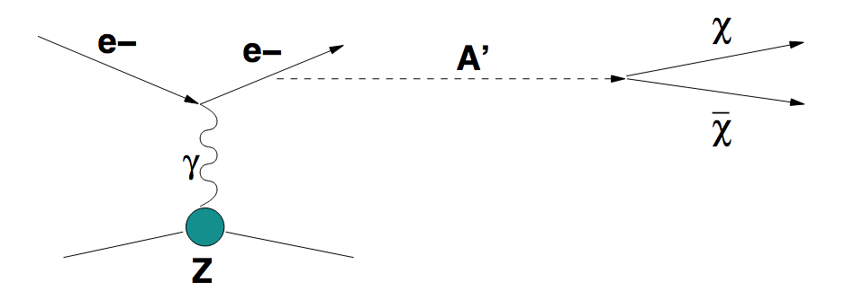
Figure 1. Diagram illustrating the massive A′ production in the reaction e−Z → e−ZA′ of
electrons scattering off a nuclei (A,Z) with the subsequent A′ decay into a χ ̄χ pair.

The process of the dark photon production and subsequent invisible decay A′ →invisible is expected to be a very rare event. It is expected to occur with the rate ≤10⁻¹⁰ with respect to the ordinary photon
production rate. Hence, its observation presents a challenge for the detector design and
performance.
The method of the search is the following: the A′s are produced through the mixing with bremsstrahlung photons from the electrons scattering off nuclei in the ECAL. The reaction e−Z → e−ZA′ A'→ invisible typically occurs in the first few radiation length (X0) of the detector.The bremsstrahlung A′ then decays in flight into two dark matter particles, which apenetrate the rest of the setup without interaction. The fraction f of the primary beam energy E₁ = f E_{e-} is deposited in the ECAL. The ECAL’s downstream part is served as a dump to absorb completely the electo-magnetic shower tail. For the total thickness of the ECAL ≃ 40 X₀ (rad. lengths) the energy leak from the ECAL is negligibly small. The remained part of the primary electron energy E₂ = (1 − f )E_{e-} is carried away by the products of the decay A′ → invisible. In order to suppress background due to inefficiency of detection, the detector must be longitudinally completely hermetic. To enhance detector hermeticity, a hadronic calorimeter (HCAL) with a total thickness ≃ 15 − 20 λ_{int} is placed behind the ECAL, as shown in Fig. 2. The ECAL calorimeter could provide accurate measurements of the lateral and longitudinal shower shape. We use PbSc sandwich with 6x6 matrix and cells 38x38x490 mm³ with energy resolution ~9%/√E(GeV).
Figure 2: The Na64 setup and working principle for the search for dark photons through missing energy in the active target (ECAL). Section up to the ECAL responces on the reconstruction of the incoming particle ID and momentum.
The occurrence of A′ → invisible decays produced in e−Z interactions would appear as an excess of events with a single e-m showers in the ECAL and zero energy deposition in the rest of the detector, above those expected from the background sources.

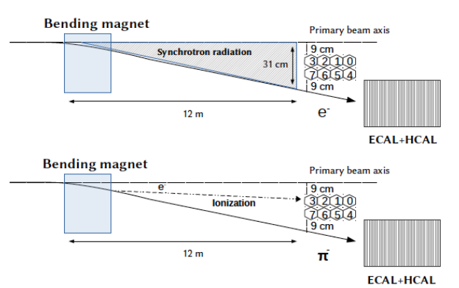

Figure 3. The scheme of the additional tagging of high energy electrons in the beam by using the
electron synchrotron radiation in the banding magnetic dipole. The synchrotron radiation photons
are detected by a γ - detector by using the LYSO inorganic crystal (Sc) capable of operating in
vacuum. The crystal is viewed by a high quantum efficiency photodetector, e.g. PMT, SiPM, or
APD. Sinchrotron radiation emission is ~1/m⁴ and the suppression of beam imputity > 10⁵.
The signal candidate events should meet the following selection criteria:
• The starting point of (e-m) showers in the ECAL should be localized within a few first X0s.
• The lateral and longitudinal shapes of the shower in the ECAL are consistent with an electromagnetic one. The fraction of the total energy deposition in the ECAL1 is f < 0.5.
• No energy deposition in the HCAL

One of the main background sources is related to the low-energy tail in the electron energy distribution in the primary beam. The origin of the low-energy tail is caused by the beam electron interactions with a passive material in the beam, such e.g. as entrance windows of the beam lines, residual gas, etc. Another source of the low energy tail is related to the pion or muon decays in flight in the beam line.
To improve the primary high energy electrons selection and additionally suppress background from the possible presence of low energy electrons in the beam typically with an energy < 0.1E_{e-} (see below), one can use a high energy e⁻-tagging system utilizing the synchrotron radiation (SR) from high energy electrons in a dipole magnet, as schematically shown in Fig. 3. The basic idea is that, since the critical SR photon energy is ~ E_{e-}³, the low energy electrons in the beam could be rejected by using the corresponding cut.
The hadronic background can be, for example, due to beam hadrons misidentified as electrons. This background is caused by some pion, proton, etc. contamination in the electron beam. Another source of this type of background is caused by the hadron electroproduction in the ECAL. Expected conservative contributions to the total level of background from different background sources estimated for the beam energy 100 GeV < 10⁻¹².

The experiment to search for the decay A′ → e⁺e⁻

The experimental setup modification specifically designed to search for the A′ → e⁺e⁻ decays is schematically shown in Fig. 4.

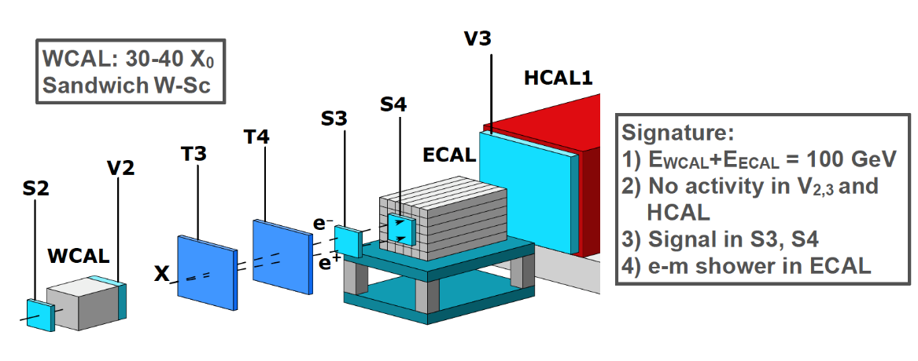

Figure 4. Schematic illustration of the setup modernisation to search for dark photons in a light-shining-through-a-wall type experiment at high energies. The incident electron energy absorption in the calorimeter WCAL is accompanied by the emission of bremsstrahlung A′s in the reaction eZ → eZA′ of
electrons scattering on nuclei, due to the γ − A′ mixing. The part of the primary beam energy is
deposited in the WCAL, while the rest of the total energy is transmitted by the A′ through the
“WCAL wall”. The A′ penetrates the WCAL without interactions and decays in flight into a narrow e⁺e⁻ pair, which generates the second electromagnetic shower in the ECAL resulting in the two-shower signature in the detector. The sum of energies deposited in the WCAL+ECAL is equal to the primary beam energy.

In this experimental mode WCAL is an active target. The remained part of the primary electron energy E₂ = (1 − f )E_{e-} is transmitted trough the “WCAL wall” by the A′ and deposited in the second downstream calorimeter ECAL via the A′ decay in flight, as shown in Fig. 4. At high A′ energies E_{A′} > 30 GeV, the opening angle Θ_{e+e−} ≃ M_{A′} /E_{A′} of the decay e⁺e⁻ pair is too small to be resolved in two e-m showers in the ECAL, so the pairs are mostly detected as a single electromagnetic shower. At distances larger than ≃ 5 m from the WCAL, the distance between the hits is > 5 mm, so the e⁺e⁻ pair can be resolved in two separated tracks in the S1 and S2. The occurrence of A′ → e⁺e⁻ decays produced in e⁻Z interactions would appear as an excess of events with two e-m-like showers in the detector (Fig. 4) above those expected from the background sources.

The experiment to search for dark sector particles weakly coupled to muon

The NA64 collaboration proposes to carry out further searches for dark sector and other rare processes in missing energy events from high energy muon interactions in a hermetic detector at the CERN SPS. A dark sector of particles predominantly weakly-coupled to the second and possibly third generations of the Standard Model is motivated by several theoretically interesting models. Additional to gravity this new very weak interaction between the visible and dark sector could be mediated either by a scalar (Sμ) or U'(1) gauge bosons (Zμ) interacting with ordinary muons. In a class of Lμ - Lτ models, the corresponding Zμ could be light and have the coupling strength lying in the experimentally accessible region. If such Zμ mediator exists it could also explain the muon (g - 2) μ anomaly - the discrepancy between the predicted and measured values of the muon anomalous magnetic moment. We propose an extension of the experiment called NA64μ to search for invisible decays of the Zμ either to neutrinos or light Dark Matter particles. The draw of the experimental setup is presented in Fig.5.

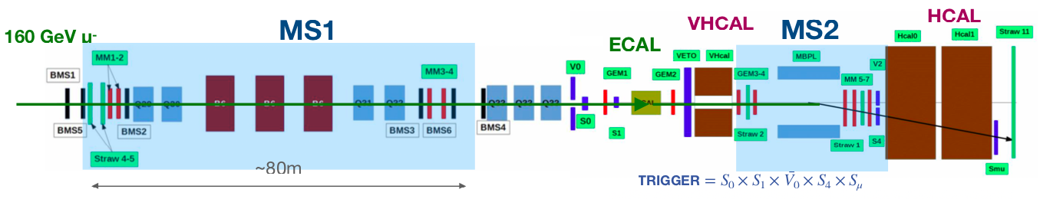
Figure 5. Schematic illustration of the setup for DM search with the CERN high enegry muon beam.

The detector shown in Fig. 5 utilizes two magnetic spectrometers upstream (MS1) and downstream (MS2) of the target. Spectrometers aimed at independent measurements of the muon momentum and high purity reconstruction of the initial and final muon state, respectively. The tracker system is a set of low-material budget Micromegas, GEM and straw-tube chambers allowing the reconstruction and precise measurements of momenta for incident and outgoing muons. The active target is a high-effciency electromagnetic calorimeter (ECAL. Downstream of the target the detector is equipped with a high effciency veto HCAL (VHCAL) with a small entrance hole and a massive, hermetic hadronic calorimeter (HCAL) located at the end of the setup all serving against charged and neutral secondaries produced from the muon interaction in the target. The HCAL consists of several modules, each with lateral and longitudinal segmentation. To enhance its hermeticity, the HCAL thickness is chosen to be ~ 30 λint (nuclear interaction lengths).
The method of the search is as follows: the bremsstrahlung Zμ are produced in the reaction μ + Z → μ' + Z + Zμ which occurs uniformly over the length of the target (T). A fraction (f) of the primary beam energy E'μ= fEμ is carried away by the scattered muon, which is detected by the second magnetic spectrometer, as shown in Fig. 5, tuned for the scattered muon momentum p'μ < pμ. The remaining part of the primary muon energy (1-f)Eμ is carried away beyond all the subdetectors resulting in the missing energy Emiss = Eμ - E'μ.
The occurrence of Zμ produced in μ-Z interactions would appear as an excess of events with a single scattered muon with energy less than initial accompanied by zero-energy deposition in the detector, as shown in Fig. 5, above those expected from the background sources.

2.2.3. A description of the scientific work undertaken and the results obtained.

The proposal (P348) to search for Dark Sectors at the CERN Super Proton Synchrotron (SPS) [1] was positively received by the SPS committee (SPSC) in April 2014. The test beam run was granted in 2015 for a feasibility study, and the proposal was finally approved as the 64th CERN experiment in the North Area (NA64) in March 2016. NA64 is designed as a hermetic general-purpose detector to search for Dark Sector (DS) physics in missing energy events from electron/positron, hadron, and muon scattering off nuclei. The main focus of the NA64 is Light thermal Dark Matter (LDM) interacting with the Standard Model (SM) via vector (or other) portal, such e.g. as dark photons (A′) and a variety of New Physics scenarios. The experiment, in electron mode (NA64e), employs the optimized 100 GeV electron beam from the H4 beam-line at the North Area. The beam was designed to transport the electrons with the maximal intensity up to a few 10⁷ per SPS spill of 4.8 s in the momentum range between 50 and 150 GeV/c. The hadron contamination in the electron beam was measured to be at a level of π/e⁻ < 2% and K/e⁻ < 0.3%. The NA64 experiment run from 2016 until 2018, and after the CERN long shutdown (LS2) in 2021, it resumed data taking in a new permanent location at H4 beamline CERN prepared for us. Despite the experiment being quite new, very interesting results were rapidly achieved [2–4]. In this contribution, we review the main results accomplished so far subdividing those into the A′ decay modes being explored.
Invisible mode: NA64 pioneered the active beam dump technique combined with the missing energy measurement to search for invisible decays of massive A′, produced in the ECAL target (the electromagnetic (em) calorimeter) by the dark Bremsstrahlung reaction e−Z → e−ZA′, where electrons scatter off a nucleus of charge Z. After its production, the A′ would promptly decay into a pair of LDM candidate particles, A′ → χχ, which would escape the setup undetected leaving missing energy as a signature. For this reason, we call these searches invisible. The parameter space characterized by mixing strengths 10⁻⁶ < ε < 10⁻³ and masses m_{A′} in the sub-GeV range is the NA64 physics scope: a region where the DM origin can be explained as a thermal freeze-out relic. Missing energy experiments, such as NA64, require precise knowledge of the incoming beam (momentum and particle ID) and an accurate measurement of the deposited energy from the incoming beam’s interaction. A signal event is defined as a single electromagnetic shower in the ECAL with an energy E_{ECAL} below the given threshold1 accompanied by a significant missing energy E_{miss} = E_{A′} = E_{initial} − E_{ECAL}. The occurrence of the A′ production is inferred in case these events show an excess above those expected from backgrounds. In Fig. 1, we present a sketch of the setup and a summary of the NA64 working principle. The signal yield for an active beam approach is proportional to ε², thus, enhancing the sensitivity for NA64 with respect to the yield ∝ α_{D}ε⁴ in traditional beam-dump approach where the A′ decay is measured in a detector further away from its production point in the dump.

Figure 1: Na64 setup and working principle for the search of dark photons through missing ebergy in the active target (ECAL). Section up to the ECAL responces on the reconstruction of the incoming particle ID and momentum.

The main results achieved so far in the invisible electron mode are:
In 2016-2018 data taking runs: 3 · 10¹¹ electrons on target (EOT) have been collected. No signal-like event was detected. However, the results of the combined analysis, illustrated in Fig. 2, set the most stringent limit for LDM below 0.1 GeV for the canonical benchmark parameters α_{D} = 0.1 and m_{A′} = 3m_{χ}, thus, NA64 became the leading beam-dump experiment in this region. Besides this, obtained data excludes most of the favored region of parameter space compatible with the muon g − 2 anomaly depicted as a band in the left plot of Fig.2. After our results were published, BABAR completely closed the remaining region of parameter space which could provide an explanation as the Dark photon contributing to the g-2 muon [5]. These results were selected as PRL editor’s suggestion [6].
In addition to the Bremsstrahlung reaction, the resonant A′ production channel through the e⁻ annihilation with the positrons present in the electromagnetic shower has also been considered. The 90% C.L. exclusion limits from the combined analysis are shown in Fig. 2. The inclusion of the resonant process in the data analysis allows enhancing the NA64 sensitivity for a given dark photon mass resulting in a peak around 200 MeV. The addition of this process improves the NA64 sensitivity in the high mass region, where the Dark photons yield is suppressed due to the 1/m²_{A′} dependency of the Bremsstrahlung cross-section (see [6]). Using positrons as a primary beam instead of electrons would increase by another order of magnitude the sensitivity of NA64 at a given mass depending on the beam energy. By scanning the positron beam energy the mass range probed by this mode can be further expanded. The drawback is that one has to deal with about an order of magnitude more hadron contamination in the beam since the secondary particles are created by the primary 400 GeV SPS protons and thus positively charged hadrons are more abundant than their negative counterpart. To study the impact of the increased hadron contamination and the possible resulting background, a first test beam with 100 GeV positron was taken during the 2022 run (see below). Electron/positron beam-dump experiments allow exploring alternative scenarios to the dark photon hypothesis. NA64 has already proven its potential to search for light-scalar and pseudo-scalar axion-like particles (ALPs) produced through the Primakoff reaction [7]. The current NA64 coverage in these searches closes part of the gap between beam-dump and LEP bounds and it is shown in the right plot of Fig. 3. A search for a generic X-boson coupling to electrons could also be performed. We were positively surprised that the NA64 sensitivity was an order of magnitude more stringent than precision experiments [8]. However, one should note that in NA64 we assume the X-boson to decay invisibly while the electron g-2 [9] and the fine structure measurements [10, 11] are
model-independent.
Figure 2: Current status of NA64 experiment 90% C.L. exclusion limits on A’ invisible decays including both the Bremsstrahlung and the resonant A’ production channeks (left) LDM searches (right) [6]

Visible mode: The method for the search of A′ → e⁺e⁻ (X → e⁺e⁻) decays is described in [1, 12]. In this case, the setup is slightly modified to include an additional compact calorimeter upstream with respect to the ECAL. If the A′ exists, due to the A′(X) − e⁻ coupling it would occasionally be produced by a shower electron (or positron) in its scattering off a nucleus in the dump: e⁻ + Z → e⁻ + Z + A′(X); A′(X) → e⁺e⁻. Since the A′ is penetrating, it would escape the beam dump and subsequently decay into an e⁺e⁻ pair in a downstream set of detectors. The pair energy would be equal to the energy missing from the target. Thus, the signature of the A′(X) → e⁺e⁻ decay is an event with two em-like showers in the detector: one shower in the dump, and another one in the ECAL, located downstream
in this case, with the sum energy being equal to the beam energy.
In 2017-2018 runs: ~ 10¹¹ EOT were accumulated. No candidates were found in the signal box. These results set the first limits on the X − e⁻ coupling in the range 1.2 × 10⁻⁴ < ε_{e} < 6.8 × 10⁻⁴ excluding part of the parameter space suggested by the so called Beryllium anomaly [13] which could be explained by a new X boson with a mass around 17 MeV (named X17) [14]. In addition, new bounds are set on the mixing strength of photons with dark photons (A′) from non-observation of the decay A′ → e⁺e⁻ of the Bremsstrahlung A′ with a mass < 23 MeV. The corresponding paper was highlighted as an editor’s suggestion in Phys. Rev. Lett. 5 [4] and in Phys. Rev. D Rapid [15]. Recently, these searches have been extended also to a pseudo-scalar particle decaying visibly into a lepton pair and the result has been published in Phys. Rev. D [16].

To completely cover the remaining region of parameter space a new shorter optimized WCAL and a new spectrometer with the possibility to reconstruct the X17 invariant mass should be used as proposed in [17]. Everything has been prepared and is ready for installation. However, since it cannot run in parallel with the invisible mode setup we decided to postpone this search. About 30 days of beam-time would be required to solidly probe the remaining X17parameter space, therefore if the results from PADME currently taking data [18], would confirm this anomaly we would be able to cross-check this in the 2024 run.
Semi-visible mode: Alternative extended scenarios envisioning two DM species split in mass could result in a signature that is a combination of the two signatures described above. A very intriguing feature of this channel is related to the possibility to recover both the DM thermal freeze-out and the (g − 2)_{μ} anomaly explanations, by evading the existing experimental constraints on pure visible and invisible modes [19]. These types of models are known as inelastic DM and we refer to their signatures as a semi-visible channel. An analysis based on a recast of the results from the combined 2016-2018 data [20] (see the left plot of Fig. 3) has already demonstrated the potential of NA64 to study these models.
Figure 3:Current status of the NA64 experiment 90% C.L. exclusion limits on semi-visible A’ decays [20] (left) visible decays (center) [15] and NA64 coverage in ALPs searches [21] (right)

Current status and prospects of NA64
The very dense NA64 program restarted after LS2 in August 2021 with the installation of the setup in the new permanent experimental area in the H4 SPS beam line. The setup was ready for the 6 weeks beam-time in 2021 and took data during 10 weeks in 2022. The goal is to continue our DS exploration until LS3 and collect around 5 · 10¹² EOT in order to probe the parameter space for light DM models suggested by the observed relic density and other interesting New Physics scenarios. Depending on the results of PADME, in 2024 the upgraded visible setup could be installed to probe the full parameter space of the hypothetical X17 boson.
Combining the 2021 data with the one collected before LS2 (total statistic of 3.2 · 10¹¹ electrons on target), weperformed a search for a new Z′ gauge boson associated with (un)broken B-L symmetry [22]. No signal events were found, thus, new constraints on the Z′-e coupling strength were set. For the mass range 0.3 < m_{Z′} < 100 MeV, these limits are more stringent than those obtained from the neutrino-electron scattering data (see Fig. 4. The data also indicate that NA64 is background free at a level of 1 × 10¹². Another possibility that is currently under investigation is based on the existence of a light Z′ boson resulting from gauging the difference of the lepton number between the muon and tau flavor. This hypothetical boson can couple via QED vertex corrections to the electron and its existence could explain both the muon g-2 anomaly and the DM relic composition. Moreover, this Z′ can be produced again through the dark Bremsstrahlung process, e⁻N → e⁻N Z′, but also via the resonant annihilation with secondary positrons from the shower. With the 2016-2018 statistics, NA64 was able to probe in this scenario the region suggested by the (g − 2)_{μ} anomaly up to m_{Z′} ∼ 1 MeV [23]. Such a light Z′ can additionally couple directly to muons and its search is therefore also one of the physics goals of NA64μ, the NA64 extension using a high energetic muon beam [24, 25].
Figure 4: Left: NA64 limits for a generic X boson, for the scalar (S), vector (V), pseudo-scalar (P) and asial vector (A) cases [8]. Center: NA64e exclusion limit for the L _{μ} – L_{τ} (red line) obtained with 2016-2018 statistics for models where Z’ can decay to DM particles [23]. The red dashed curves present the sensitivity projections for a future NA64e runs with an elelctron (positron) beam, for a total of 10¹³ EOT, while the green dashes curve is the sensivity projection of NA64_{μ.} Right: NA64 exclusion limits for a new B-L Z’ boson [22].

The NA64μ program started in 2021 with two pilot runs at the M2 beam-line using the unique CERN 160 GeV/c muon beam. This will probe DS in a complementary way to the H4 measurements with electrons and will address the g-2 muon anomaly [25]. The main difference between the experimental technique used in NA64μ compared to NA64e is that in this case one has to rely solely on momentum reconstruction to measure the missing energy carried away from a possible Z′ or A′ decay. This makes NA64μ much more challenging than NA64e where one employs calorimeters for this purpose. During the pilot runs in 2021 and 2022, a total of 4 · 10¹⁰ MOT were collected. The analysis is still ongoing but the preliminary results already hint to the fact that an additional spectrometer should be added upstream the ECAL since an accurate determination of the incoming momentum is crucial for the experiment. This will be tested in 2023 and the first physics runs are expected for 2024-2025. It is worth mentioning, that for the new-physics process simulations and for detailed comparison between data and Monte Carlo, a new GEANT4 based package called DMG4 [26] was developed by NA64 members, which has been well accepted by the community, see, e.g [27].

Outlook and conclusions
NA64 just reached a major milestone of accumulating ∼ 10¹² EOT which allows one to start probing very interesting LDM benchmark models. The analysis is ongoing and with the increased statistics we expect to improve the sensitivity also of our searches for ALPs, L_{μ}-L_{τ} and B-L Z′ bosons, inelastic DM and generic X bosons. The plan until LS3 is to accumulate as many as possible electrons on target (up to 5·10¹²) and if the background will be under control also use the positron mode to enhance the sensitivity in the higher A′ mass region. To study the impact of the larger hadron contamination when running with positrons compared to electrons, in the 2022 run 2 days were used to collect ∼ 10¹⁰ positrons on target (the analysis is ongoing).
NA64 also started its program at the M2 beam-line providing unique high intensity 160 GeV muons to explore dark sectors weakly coupled to muons. The results of the pilot runs show that with an optimized setup, one could collect > 10¹¹ MOT before LS3 in order to check if an L_{μ}-L_{τ} Z′ boson is the explanation of the g-2 muon anomaly and complement the searches with electrons (see [28]). After LS3 the experiment would then continue data taking to accumulate ∼ 10¹³ MOT to explore the A′ higher mass region and μ → τ and μ → e LFV processes [29].
In the 2022 beam-time, we also dedicated 1 day of data taking to accumulate ∼ 2 × 10⁹ pions on target in order to understand the potential of NA64 to explore dark sectors coupled predominantly to quarks using the missing energy technique [30, 31]. This will be further investigated and, if the feasibility would be demonstrated, a dedicated search will be performed after LS3.
To conclude the exploration of the NA64 physics potential has just begun. Our proposed searches with leptonic and hadronic beams provide unique sensitivities highly complementary to similar projects.

References
[1] S. Andreas, P. Crivelli, et al. Proposal for an Experiment to Search for Light Dark Matter at the SPS. 2013.
[2] D. Banerjee, P. Crivelli, et al. Search for invisible decays of sub-GeV dark photons in missing-energy events at the CERN SPS. Phys. Rev. Lett., 118(1):011802, 2017.
[3] D. Banerjee, P. Crivelli, et al. Search for vector mediator of Dark Matter production in invisible decay mode. Phys. Rev., D97(7):072002, 2018.
[4] D. Banerjee, P. Crivelli, et al. Search for a Hypothetical 16.7 MeV Gauge Boson and Dark Photons in the NA64 Experiment at CERN. Phys. Rev. Lett., 120(23):231802, 2018.
[5] J. P. Lees et al. Search for Invisible Decays of a Dark Photon Produced in e+e− Collisions at BaBar. Phys. Rev. Lett., 119(13):131804, 2017.
[6] D. Banerjee et al. Dark matter search in missing energy events with NA64. Phys. Rev. Lett., 123(12):121801, 2019.
[7] D. Banerjee et al. Search for Axionlike and Scalar Particles with the NA64 Experiment. Phys. Rev. Lett.,125(8):081801, 2020.
[8] Yu. M. Andreev et al. Constraints on New Physics in Electron g − 2 from a Search for Invisible Decays of aScalar, Pseudoscalar, Vector, and Axial Vector. Phys. Rev. Lett., 126(21):211802, 2021.
[9] X. Fan, T. G. Myers, B. A. D. Sukra, and G. Gabrielse. Measurement of the Electron Magnetic Moment. 9 2022.
[10] Richard H. Parker, Chenghui Yu, Weicheng Zhong, Brian Estey, and Holger M ̈uller. Measurement of the fine-structure constant as a test of the Standard Model. Science, 360:191, 2018.
[11] L ́eo Morel, Zhibin Yao, Pierre Clad ́e, and Sa ̈ıda Guellati-Kh ́elifa. Determination of the fine-structure constant with an accuracy of 81 parts per trillion. Nature, 588(7836):61–65, 2020.
[12] S. N. Gninenko. Search for MeV dark photons in a light-shining-through-walls experiment at CERN. Phys. Rev., D89(7):075008, 2014.
[13] A. J. Krasznahorkay et al. Observation of Anomalous Internal Pair Creation in Be8 : A Possible Indication of a Light, Neutral Boson. Phys. Rev. Lett., 116(4):042501, 2016.
[14] Jonathan L. Feng, Bartosz Fornal, Iftah Galon, Susan Gardner, Jordan Smolinsky, Tim M. P. Tait, and Philip Tanedo. Particle physics models for the 17 MeV anomaly in beryllium nuclear decays. Phys. Rev., D95(3):035017, 2017.
[15] D. Banerjee et al. Improved limits on a hypothetical X(16.7) boson and a dark photon decaying into e+e− pairs. 2019.
[16] Yu. M. Andreev et al. Search for pseudoscalar bosons decaying into e+e− pairs in the NA64 experiment at the CERN SPS. Phys. Rev. D, 104(11):L111102, 2021.
[17] E. Depero et al. Hunting down the X17 boson at the CERN SPS. Eur. Phys. J. C, 80(12):1159, 2020.
[18] Luc Darm ́e, Marco Mancini, Enrico Nardi, and Mauro Raggi. Resonant search for the X17 boson at PADME. 9 2022.
[19] Gopolang Mohlabeng. Revisiting the dark photon explanation of the muon anomalous magnetic moment. Phys. Rev. D, 99:115001, Jun 2019.
[20] C. Cazzaniga et al. Probing the explanation of the muon (g-2) anomaly and thermal light dark matter with the semi-visible dark photon channel. Eur. Phys. J. C, 81(10):959, 2021.
[21] Sergei Gninenko. NA64 Status Report 2018. Technical Report CERN-SPSC-2018-015. SPSC-SR-231, CERN, Geneva, May 2018.
[22] Yu. M. Andreev et al. Search for a New B-L Z’ Gauge Boson with the NA64 Experiment at CERN. Phys. Rev. Lett., 129(16):161801, 2022.
[23] Yu. M. Andreev et al. Search for a light Z’ in the Lμ-Lτ scenario with the NA64-e experiment at CERN. Phys. Rev. D, 106(3):032015, 2022.
[24] S. N. Gninenko, N. V. Krasnikov, and V. A. Matveev. Muon g-2 and searches for a new leptophobic sub-GeV dark boson in a missing-energy experiment at CERN. Phys. Rev. D, 91:095015, 2015.
[25] H. Sieber, D. Banerjee, P. Crivelli, E. Depero, S. N. Gninenko, D. V. Kirpichnikov, M. M. Kirsanov, V. Poliakov, and L. Molina Bueno. Prospects in the search for a new light Z’ boson with the NA64μ experiment at the CERN SPS. Phys. Rev. D, 105(5):052006, 2022.
[26] M. Bondi, A. Celentano, R. R. Dusaev, D. V. Kirpichnikov, M. M. Kirsanov, N. V. Krasnikov, L. Marsicano, and D. Shchukin. Fully Geant4 compatible package for the simulation of Dark Matter in fixed target experiments. Comput. Phys. Commun., 269:108129, 2021.
[27] Tom Eichlersmith, Jeremiah Mans, Omar Moreno, Joseph Muse, Michael Revering, and Natalia Toro. Simulation of Dark Bremsstrahlung in GEANT4. 11 2022.
[28] S. N. Gninenko, D. V. Kirpichnikov, M. M. Kirsanov, and N. V. Krasnikov. Combined search for light dark matter with electron and muon beams at NA64. Phys. Lett. B, 796:117–122, 2019.
[29] S. N. Gninenko and N. V. Krasnikov. Leptonic scalar portal: Origin of muon g-2 anomaly and dark matter? Phys. Rev. D, 106(1):015003, 2022.
[30] S. N. Gninenko. Search for invisible decays of π0, η, η′, KS and KL: A probe of new physics and tests using the Bell-Steinberger relation. Phys. Rev. D, 91(1):015004, 2015.
[31] S. N. Gninenko and N. V. Krasnikov. Invisible KL decays as a probe of new physics. Phys. Rev. D, 92(3):034009, 2015

2.2.4. A list of the main publications of JINR authors, including associated personnel on the results of the project work (list of bibliographical references).

- Improved limits on a hypothetical X(16.7) boson and a dark photon decaying into e⁺e⁻ pairs. D. Banerjee (CERN and Illinois U., Urbana (main)), J. Bernhard (CERN), V.E. Burtsev (Dubna, JINR), A.G. Chumakov (Tomsk Pedagogical Inst.), D. Cooke (University Coll. London), P. Crivel и др., Phys.Rev.D, 101,7, 071101, 2020
- Hunting down the X17 boson at the CERN SPS. NA64 Collaboration, The European Physical Journal C - Particles and Fields, Изд:Springer, 80, 2020
- Improved limits on a hypothetical X(16.7) boson and a dark photon decaying into e+e- pairs
N.V.Krasnikov et al.(NA64 Collaboration), Physical Review D, ISSN:1550-7998, eISSN:1550-2368, Изд:American Physical Society, D101, 7, 071101-071109, 2020
- Search for Axionlike and Scalar Particles with the NA64 Experiment. N.V.Krasnikov et al.(NA64 Collaboration), Physical Review Letters, ISSN:0031-9007, eISSN:1079-7114, Изд:American Physical Society, 125, 081801, 2020
- Improved exclusion limit for light dark matter from e+e- annihilation in NA64. NA64 collaboration, Phys.Rev.D, 104, 9, 2021
- Constraints on New Physics in Electron g-2 from a Search for Invisible Decays of a Scalar, Pseudoscalar, Vector, and Axial Vector. NA64 Collaboration, Phys.Rev.Lett., 126, 21, 2021
- Search for pseudoscalar bosons decaying into e+e- pairs in the NA64 experiment at the CERN SPS. NA64 collaboration, Phys.Rev.D, 104, 11, 2021 .
- Search for a light Z’ in the L_{μ} - L_{τ} scenario with the NA64-e experiment at CERN. Phys.Rev.D, 106, 3, 32015, 2022
- Search for a New B - L Z’ Gauge Boson with the NA64 Experiment at CERN. Phys.Rev.Lett., 129, 161801, 2022
- MiniSPD Stand for Testing Si-Detectors, Published in: Nonlin.Phenom.Complex Syst. 25 (2022) 3, 254-265, Published: 2022
- VMM3 ASIC as a potential front end electronics solution for future Straw Trackers, Nuclear Instruments and Methods in Physics Research Section A: Accelerators, Spectrometers, Detectors and Associated Equipment, Volume 1047, February 2023, 167864

2.2.5. A complete list of publications (electronic annex, for journal publications with journal impact factor).
- Improved limits on a hypothetical X(16.7) boson and a dark photon decaying into e⁺e⁻ pairs. D. Banerjee (CERN and Illinois U., Urbana (main)), J. Bernhard (CERN), V.E. Burtsev (Dubna, JINR), A.G. Chumakov (Tomsk Pedagogical Inst.), D. Cooke (University Coll. London), P. Crivel и др., Phys.Rev.D, 101,7, 071101, 2020
- Hunting down the X17 boson at the CERN SPS. NA64 Collaboration, The European Physical Journal C - Particles and Fields, Изд:Springer, 80, 2020
- Improved limits on a hypothetical X(16.7) boson and a dark photon decaying into e+e- pairs
N.V.Krasnikov et al.(NA64 Collaboration), Physical Review D, ISSN:1550-7998, eISSN:1550-2368, Изд:American Physical Society, D101, 7, 071101-071109, 2020
- Search for Axionlike and Scalar Particles with the NA64 Experiment. N.V.Krasnikov et al.(NA64 Collaboration), Physical Review Letters, ISSN:0031-9007, eISSN:1079-7114, Изд:American Physical Society, 125, 081801, 2020
- Improved exclusion limit for light dark matter from e+e- annihilation in NA64. NA64 collaboration, Phys.Rev.D, 104, 9, 2021
- Constraints on New Physics in Electron g-2 from a Search for Invisible Decays of a Scalar, Pseudoscalar, Vector, and Axial Vector. NA64 Collaboration, Phys.Rev.Lett., 126, 21, 2021
- Search for pseudoscalar bosons decaying into e+e- pairs in the NA64 experiment at the CERN SPS. NA64 collaboration, Phys.Rev.D, 104, 11, 2021 .
- Search for a light Z’ in the L_{μ} - L_{τ} scenario with the NA64-e experiment at CERN. Phys.Rev.D, 106, 3, 32015, 2022
- Search for a New B - L Z’ Gauge Boson with the NA64 Experiment at CERN. Phys.Rev.Lett., 129, 161801, 2022
- MiniSPD Stand for Testing Si-Detectors, Published in: Nonlin.Phenom.Complex Syst. 25 (2022) 3, 254-265, Published: 2022
- VMM3 ASIC as a potential front end electronics solution for future Straw Trackers, Nuclear Instruments and Methods in Physics Research Section A: Accelerators, Spectrometers, Detectors and Associated Equipment, Volume 1047, February 2023, 167864

Electronic publications and preprints:

- Constraints on New Physics in the Electron g-2 from a Search for Invisible Decays of a Scalar, Pseudoscalar, Vector, and Axial Vector. Yu.M. Andreev, D. Banerjee, J. Bernhard, V.E. Burtsev, A.G. Chumakov, D. Cooke, P. Crivelli, E. Depero, A.V. Dermenev, S.V. Donskov, R.R. Dusaev, T. Enik, N. Charitonidis, A.Feshchenko, V.N. Frolov, A.Gardikiotis, S.G. Gerassimov, S.N. Gninenko, M. Hosgen, V.A. Kachanov, A.E. Karneyeu, G. Kekelidze, B. Ketzer, D.V.Kirpichnikov, M.M. Kirsanov, V.N. Kolosov, I.V. Konorov, S.G. Kovalenko, V.A. Kramarenko, L.V. Kravchuk, N.V. Krasnikov, S.V. Kuleshov, V.E. Lyubovitskij, V.Lysan, V.A. Matveev, Yu.V. Mikhailov, L и др., CERN-EP-2021-017, 2021
- Search for pseudoscalar bosons decaying into e⁺ e⁻ pairs. NA64 Collaboration, e-Print: 2104.13342 [hep-ex] CERN Document Server, ADS Abstract Service, 2021
- Probing the explanation of the muon (g-2) anomaly and thermal light dark matter with the semi-visible dark photon channel. NA64 Collaboration, e-Print: 2107.02021 [hep-ex] ADS Abstract Service, 2021
- Search for a new B-L Z’ gauge boson with NA64. NА64 collaboration, CERN Document Server, ADS Abstract Service, 2022
- Search for a light muon-philic Z’ with the NA64-e experiment at CERN. NA64 collaboration, CERN Document Server, ADS Abstract Service, 2022
- Поиск темной материи продолжается. Пешехонов Д.В. http://www.jinr.ru/posts/poisk-temnoj-materii-prodolzhaetsya/. 2022
- Поиск темной материи в эксперименте NA64. Пешехонов Д.В. Новости ОИЯИ, №3, 2022
- Search for pseudoscalar bosons decaying into e+e- pairs. arXiv:2104.13342, 6, NA64 Collaboration, 2021

2.2.6 List of papers presented at international conferences and meetings (electronic annex).
1.«The NA64mu experiment at the CERN SPS», 6th International Conference on Particle Physics and Astrophysics,30 November 2022
2."The Na64-e experiment at CERN", Discrete 2022, 7-11 November 2022
3."Probing Dark Sector with KS,L invisible decays at" FIPs@ECN3 (June 1st, 2022)
4.Search for light dark matter in NA64 experiment, 64th International MIPT Scientific Conference
5."Recent results and plans of the NA64 experiment at the CERN SPS" , SAPHIR seminar, Chile, online, December 03, 2021
6."Fully Geant4 compatible package for the simulation of Dark Matter in fixed target experiments"
, ACAT-2021, 20th International Workshop on Advanced Computing and Analysis Techniques in Physics Research
7."Recent results and plans of the NA64 experiment at the CERN SPS" , QUARKS-2020 International Seminar on HEP, June 07 2021
8."Latest results of the NA64 experiment searching for hidden sectors at the CERN SPS" , CERN EP Seminar, 25th of May 2021
9.Latest results of Na64 experiment @CERN, Kashiwa Dark Matter symposium 2020 16-19th, November 2020
10.Search for LDM and Vector/ALPs mediators in the sub-GeV mass range at NA64, NA62, MESA, PADME, Feebly Interacting Particles 2020, 31 August - 4 September 2020
11.Трековые детекторы с тонкостенными трубками в физике элементарных частиц, 55-я зимняя школа Петербургский Институт Ядерной Физики НИЦ «Курчатовский институт», 2023
12. 57th PAC, The NA64mu experiment at the CERN SPS, poster, 2023
13.AYSS, Simulation of the straw detector in the NA64 experiment for the muon run, section report, 2022
14.AYSS New physics search, seminar, 2022
15.IV International Scientific Forum “Nuclear science and Technologies”, Straw chambers for the NA64 experiment, poster, 2022
16.AYSS, Data Acquisition System of the NA64 Experiment, section report, 2022
17.The XXVI International Scientific Conference of Young Scientists and Specialists, Online Gas Gain Monitoring System, (AYSS-2022)

2.2.7. Patent activity (if any)

2.3. Status and stage (TDR, CDR, ongoing project) of the project (subproject) (including percentage of implementation of the declared milestones of the project (subproject of the LRIP) (if applicable) ongoing project

2.4. Results of related activities
2.4.1. Research and education activities. List of defended dissertations.
Two in progress
2.4.2. JINR grants (scholarships) received.
- 5 AYSS grantes
- RSF grant № 23-22-00041
- Grant «Базис» грант Базис № 22-1-3-57-1
2.4.3. Awards and prizes.
- JINR Encouraging Prizes in 2020,
- Report at the 57th PAC, The NA64mu experiment at the CERN SPS was nominated for the 3d
place

2.4.4. Other results (expert, scientific-organisational, scientific-propaganda activities).

3. International scientific and technical cooperation.
Actually participating countries, institutions and organisations
Organisation | Country | City | Participants | Type  of agreement
BSU | Belarus | MInsk | A.Solin+1 | Joint work
UTFSM  UAB | Chilie | Valparaiso  Santiago | S.Kuleshov + 8 | Joint work
University of Bonn | Germany | Bonn | B.Ketzer + 2 | Joint work
INFN | Italy | Genova | A.Celentano+10 | Joint work
INR RAS | Russia | Moscow, Troitsk | S.Gninenko + 9 | Joint work
IHEP | - | Protvino | V.Polyakov + 5 | Joint work
HPPI | - | Moscow | V.Tihomirov + 1 | Joint work
TPU | - | Tomsk | V.Lubovitskiy + 4 | Joint work
ETH | Switzerland | Zurich | A.Rubbia + 4 | Joint work

4. Plan/actual analysis of resources used: human (including associated personnel), financial, IT, infrastructure

4.1 Human resources (actual at the time of reporting)

№№  n/a | Category  employee | Core staff,  Amount of FTE | Associated  Personnel  Amount of FTE
1. | scientific staff | 4,8
2. | engineers | 1,5
3. | professionals
4. | employees
5. | workers | 0,2
 | Total: | 6,5

4.2 The actual estimated cost of the project/ subproject of the LRIP

Names of costs, resources,  sources of funding |  |  | Cost (thousands  of dollars)  resource requirements | Cost,  distribution by year
 |  |  |  | 1st year | 2nd year | 3rd year | 4th year | 5th year
 |  | International cooperation (IC) | 95,5 |  | 31,4 | 64,1
 |  | Materials | 65,5 | 18,5 | 26 | 21
 |  | Equipment and third-party services (commissioning) | 204 | 130 | 37 | 37
 |  | Commissioning work
 |  | Services of research organisations | 6,8 |  | 6,8
 |  | Acquisition of software
 |  | Design/construction
 |  | Service costs (planned in case of direct project affiliation)
Resources required | Normo-hours | Resources
 |  | - the amount of FTE, | 19,5 | 6,5 | 6,5 | 6,5
 |  | - accelerator/installation,
 |  | - reactor,….
Names of costs, resources, funding sources Cost (thousands of dollars) resource requirements Proposal from the laboratory for allocation of funding and resources  1 year 2 year 3 year 4 year 5 year  International cooperation (IC)  Materials  Equipment and third-party services  Commissioning work  Services of research organisations  Acquisition of software  Design/construction  Service costs (planned in case  of direct project affiliation)  Resources required Normo-hours Resources  - The amount of FTE,  - accelerator/installation,  - reactor, .......  Sources of funding Budgetary resources JINR budget (budget items  Extrabudgetary (supplementary estimates) Contributions by co-contractors Funds under contracts with customers Other sources of funding  Sources of funding | Budgetary resources | JINR budget (budget items) | 371,8 | 148,5 | 101,2 | 122,1
 | Extrabudgetary (supplementary estimates) | Contributions by  co-contractors  Funds under contracts with customers  Other sources of funding

4.3 Other resources
Computer resources consumed  MICC | Distribution by year
 | 1st year | 2nd year | 3rd year | 4th year | 5th year
Data storage (TB)
- EOS
- Ribbons
Tier 1 (core-hour)
Tier 2 (core-hour)
SC Talker (core-hour)
- CPU
- GPU
Clouds (CPU cores)

5. Conclusion
NA64 just reached a major milestone of accumulating ∼ 10¹² EOT which allows one to start probing very interesting LDM benchmark models. The analysis is ongoing, the exploration of the NA64 physics potential has just begun. Our proposed searches with leptonic and hadronic beams provide unique sensitivities highly complementary to similar projects.

6. Proposed reviewers

Theme Leader
/______________/
" " 202_г.

Project leader (02-1-1096-2-2010/2026)
/____ /
" " 202_г.

Laboratory Economist
/_______ /
" " 202_ г.

