**APPROVED**

**Director of Laboratory**

**/ V. Bednyakov /**

**" " 2023**

**REPORT ON THEME / LARGE RESEARCH INFRASTRUCTURE PROJECT**

**1. General information on the Theme / LRIP**

**1.1. Theme / LRIP code**

02-0-1081-2009/2024

**1.2. Laboratories**

DLNP, VBLHEP, MLIT, BLTP, FLNP

**1.3. Scientific field**

Elementary Particle Physics and Relativistic Nuclear Physics

**1.4. Title of the Theme / LRIP**

ATLAS. Upgrade of the ATLAS Detector and Physics Research at the LHC

**1.5. Theme / LRIP Leader**

V.A. Bednyakov

Deputies:

E. Khramov

A. Cheplakov

**1.6. Projects in the Theme / LRIP subprojects**

ATLAS. Physical researches at the LHC

Upgrade of the ATLAS Detector

**2. Scientific report on the Theme / LRIP**

**Abstract**

The main purpose of the international ATLAS experiment is to investigate proton-proton interactions at unprecedented energies at the LHC collider (from 7 to 14 TeV center-of-mass energy). In particular, detailed study of the Standard Model, its application limits, search for answers to the key problems in particle physics and astrophysics, such as origin of elementary particles masses, nature of the dark matter in the Universe, existence of extra dimensions, are carried out with the ATLAS detector.

Absolutely new and unique data will be obtained based on multifaceted and comprehensive studies of the proton-proton scattering processes. These data analyses will allow to address several fundamental problems in particle physics. Within current project, scientists from JINR are going to participate in these analyses.

Scientists from JINR will obtain new results leading to publications in all mentioned above areas. The most important tasks include studies of the proton structure and of hadron spectra, tests of the Standard Model at the LHC energies, searches for Supersymmetry, searches for new heavy particles and new interactions. Apart from new physics searches, JINR scientists will work on the precision frontier and will measure with greater accuracy the properties of known elementary particles, such as W and Z bosons, top quark, and heavy baryons.

During the 2020 – 2022 period of the project, 19 papers with significant participation of JINR staff were published, more than 17 talks at international conferences and meetings excluding working meetings within the Collaboration were delivered.

**Introduction**

The ATLAS international collaboration was established more than 30 years ago to carry out a new-generation multipurpose experiment designed to study fundamental properties of matter in proton-proton collisions at the center-of-mass energy of 14 TeV at the Large Hadron Collider (LHC). Nowadays, the Collaboration includes 2929 authors and overall ~5900 participants from 182 institutes in 42 countries. During these 30 years, very complex ATLAS detector systems were designed, constructed, commissioned, and used to successfully investigate a variety of physics phenomena, including a long-awaited Higgs boson discovery in 2012.

JINR contribution to this achievement looks very remarkable compared to other institutions. It is worth to mention that the following very important works has been carried out at JINR in full compliance with the responsibilities imposed upon JINR by the ATLAS collaboration:

1. Design, production and commissioning of the detector modules for Muon Spectrometer, Liquid argon and Tile Calorimeters, and for the Inner Tracker.

2. Calibration of the ATLAS calorimeters and preparation for data-taking.

3. Participation in the development on the ATLAS Trigger DAQ (TDAQ).

4. Creation of the ATLAS GRID at JINR (one of the best in Russia).

5. Modeling and optimization of the ATLAS magnet system.

6. Design, production and assembly of elements of the ATLAS magnet system

It is remarkable that *only Italy, USA, CERN and JINR* have contributed to all main subsystems (TileCal, Muon, LAr, ID, TDAQ) of the ATLAS detector. In 2009, JINR ATLAS project leaders explicitly stated (when the first part of the project was approved) that *the outstanding JINR contribution to design, construction, assembly and commissioning of the ATLAS detector systems should not have been in vain for JINR.*  Therefore in 2020-2022 the main goal of JINR ATLAS management was to transform the above-mentioned JINR achievements into exciting physics results obtained by (or with important contribution of) the JINR scientists.Despite several complications, this goal was successfully achieved. The extended report on the JINR ATLAS team contribution to ATLAS operation and physics results during 2020-2022 is under preparation for publication.

In short, during these 3 years in the scope of the project the JINR team strongly participated in ATLAS physics results preparation including data taking, data preparation, Monte Carlo simulation and data analysis. The team took relevant part in obligatory ATLAS Common Operation Tasks, including shifts in the CERN-ATLAS and JINR-remote-ATLAS control rooms, on-call expert jobs, data quality control (remote), etc. Standard ATLAS maintenance and operation (M&O) support was supplied by JINR experts over these years. JINR has upgraded the JINR LHC computing Grid facilities and supplied computing resources which allowed successful exploitation of the JINR-based Tier-2 ATLAS Grid fragment. The JINR team has also defined its participation scope in the general ATLAS upgrade program for the HL-LHC.

Furthermore, during realization of the ATLAS project at JINR in 2009-2022, the JINR ATLAS management has carried out its inner reorganization. The reason was a general change from construction, assembly and commissioning of the ATLAS detector sub-systems (Tile and LAr Calorimeters, Muon systems, inner TRT detectors, etc) to the ATLAS detector operation via new Common Operation Tasks (OT) like, for example, shifts in ATLAS control room, on-call expertise, data preparation, data quality tests and physics analysis. These new requirements forced some optimization of the ATLAS author list as well. Currently, participation in both Operation Tasks and Physics analyses is (as a rule) obligatory for an ATLAS author (from JINR). To strengthen responsibility of JINR people and to enhance the JINR contribution in the ATLAS project it was necessary to impose a new requirement for a membership in the JINR-ATLAS team. To fulfill it, one first had to become “visible” at the general ATLAS collaboration level before becoming an official ATLAS author. The main practical goal of this rule was to create at JINR a new efficiently working ATLAS team which can solve ambitious problems at a level of the whole ATLAS collaboration. By 2021 the goal was reached in general. In particular, the JINR team contributed substantially to ATLAS physics output on the main topics of the Standard Model, QCD, searches for Higgs boson and Supersymmetry, and general study of physics beyond the Standard Model (Exotics physics). Several new directions for physics research were proposed and put into development by JINR team members.

**Upgrade of the ATLAS detector**

It is also worth to mention that JINR provides important contribution to the upgrade of the ATLAS detector. In the Phase-I (2014-2020) of the ATLAS upgrade program the JINR team was responsible for the development of the “off-detector” electronics for the Tile calorimeter and trigger electronics for the liquid argon calorimeter. The JINR has supplied the radiation hard scintillators for replacement of MBDT modules in the transition area between the barrel and endcap cryostats. We also designed the baseplane for the new readout crate of the LAr calorimeter and developed several prototypes of the preshaper for the analog part of the LAr Trigger Digitizer Board. The most significant contribution of the JINR team in the Phase-I ATLAS upgrade project is mass production of the quadruplets for the New Small Wheel of the muon spectrometer. A special workshop was built at the Institute for the production of all outermost modules of the LM2 type for NSW: in total, until April 2021, 70 Micromegas reading panels and 33 quadruplets were manufactured. In 2021-2022, the group was actively involved in the integration, testing, commissioning and launch of NSW at CERN (see photo below).

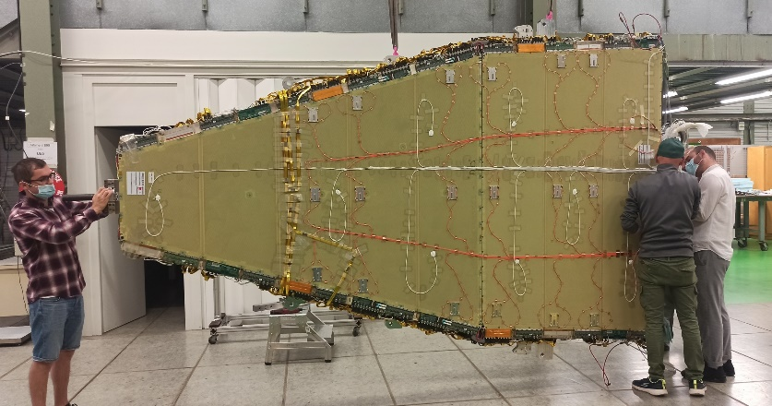

*Team members during the integration of the NSW modules (side C) and before descending into the ATLAS cavern.*

In 2021, work began on commissioning a site for the production of trigger resistive flat cameras (RPC) for the central part of the muon spectrometer (Phase 2 of the ATLAS upgrade). RPC cameras are parallel plate gas detectors that combine good spatial resolution with time resolution comparable to that of scintillators. Installing the new triplet RPC chambers in the inner layer of the central part of the muon spectrometer will significantly reduce the geometric limitations on acceptance and make the trigger system robust to degradation or failures in the old RPC chambers. The increase in acceptance and reliability of triggers will be achieved by simultaneously relaxing the trigger count requirements for the BM and BO chambers and adding the requirement of coincidence with the inner BI layer. Any coincidence of hits in at least three of the four chambers (counting one BI, two BM and one BO) is accepted. The Dubna group is responsible for the manufacture and testing of ~ 350 readout panels (so-called strip panels) or 50% of all BIL-type panels. In 2022, the production technology and methods for measuring geometric characteristics were developed. 3 panels were produced and tested. Tests have shown a high, superior to the requirements of the collaboration, the quality of the panels.

In the work on the construction of a highly granular time detector (HGTD) in 2022, the design was determined, materials were prepared and an important step in the preparation of DCS - SPR (Specification Preliminary Review) was completed. The main work in preparation for the HGTD DCS/Environmental Monitoring PDR (Preliminary Design Review) has been completed. The PDR itself took place already in February 2023. The instrumentation has been selected for use as a dew point sensor. Software has been written for it and testing has begun. A special commission of the ATLAS experiment drafted and approved the terms of reference for the development (Specification Review) of the HGTD detector half-disk assembly stand - the main components of the HGTD, which are the assembly of detector modules, peripheral electronics and services on the cooling plate. HGTD includes 8 of these half discs. Along with the assembly, the Stand should provide the ability to test and then install the assembled half disks into the HGTD case. A preliminary design of the Stand was developed, the results of the study were regularly reported at HGTD workshops. The work on the placement and design of HGTD services on the end face calorimeter of the ATLAS facility was completed, a 3D model was created. The concept of the outer ring of the HGTD case is proposed, including a way to connect and integrate services. Mock-up to test the concept was designed and created. Work was carried out to develop and refine the HGTD services and infrastructure, in particular, the terms of reference for the development (Specification Review) of the HGTD nitrogen ventilation system were prepared and approved. The assembly, installation and testing of the detector was coordinated, including the development of detailed plans and reporting on the progress of the work to the ATLAS upgrade commissions (AUG, P2UG). The proposed solutions and the progress of work on their implementation were regularly reported and discussed at the HGTD workshops.

The LHC luminosity upgrade to 7.5×1034cm-2s-1 corresponding to an average μ=200 inelastic *pp* collisions per beam-crossing will allow comprehensive measurements of the Higgs boson properties in all its production and decay modes, as well as improved measurements of all relevant Standard Model processes and searches for phenomena beyond the SM. For example, one of the most important results in the ATLAS experiment in 2018 was observation of the Higgs decay into a pair of *b*-quarks and VH production. The members of our group are working in the analysis team for many years and will continue this activity in the future. A combination of Run 2 results searching for the Higgs boson produced in association with a vector boson yields an observed (expected) significance of 5.3 (4.8) standard deviations with uncertainty above 10% for signal strength value.

Models with an extended Higgs sector, like SUSY, predict deviations of the Higgs couplings from SM predictions that can be arbitrary small if Higgs states in SUSY are very heavy. That is why the increase of statistics (and better accuracy of the measurements) is very important for the future progress of this study. Dedicated analysis showed that statistical significance value for H→bb channel of 7.1 could be obtained for the integrated luminosity of 300 fb-1, and 10.7 could be obtained for 3000 fb-1.

Therefore to meet this unprecedented value of the luminosity is crucial for all aspects of the future physics analysis and software development.

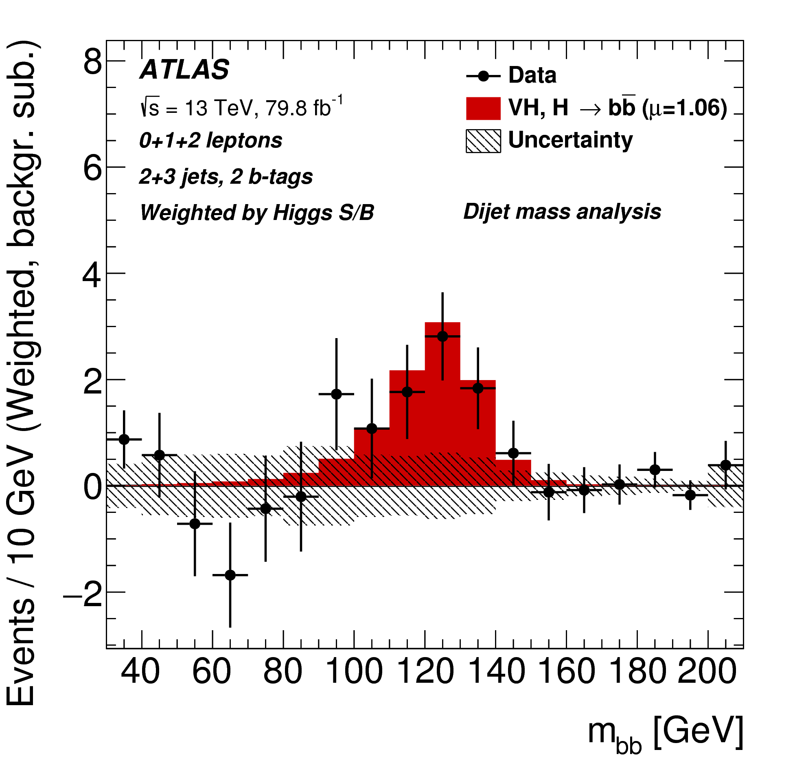

*The distribution of mbb in data, as obtained with the dijet-mass analysis after subtraction of all backgrounds.*

**Participation in the ATLAS detector operation**

JINR continues its participation in the ATLAS Common Operation Tasks. It includes shift work of JINR people in the CERN-ATLAS control rooms, fulfillment of on-call expert jobs, and data quality control, etc. Standard ATLAS maintenance and operation (M&O) support was supplied by JINR over these years as well. In particular, JINR continues participation in the running of the **Hadronic Tile Calorimeter** (Irakli Minashvivli (JINR) and Oleg Solovyanov (Aubiere) are the two main leaders of the Tile Calorimeter detector Maintenance). The LAr JINR ATLAS team continues exploitation and support of the **Liquid Argon hadronic calorimeter**. The JINR M&O obligations include refurbishment of the electronics blocks, repairing and put in order electronic blocks, monitoring of quality of read-out channels, participation in shifts as “expert-on-call” and “HEC local expert”, etc.

JINR will continues to participate in ATLAS **Safety control** efforts. In particular JINR members (V. Batusov, I. Kostyukhina, M.Shijakova) will work as SLIMOS (Shift Leader in Matter of Safety). In addition they take duties of the Radiation Gate Monitors in order to prevent any leak of radioactive materials from the ATLAS cavern.

**JINR in the ATLAS Physics**

The strategical idea of JINR participation in the ATLAS physics program is “visibility” of the JINR-team contributions. Contrary to the previous stage of the project (2015-2019, *with so-called JINR-based ATLAS preliminary activities)*any local activity in the field of ATLAS physics will not be supported at JINR if it has no clear plans to be considered, accepted and supported for development within the whole ATLAS Collaboration (or relevant ATLAS working groups).

*By taking this approach, the JINR group had* a strong participation in the following for the period of 2020-2022:

1. Study of the Standard Model applicability and verification of its predictions, study of the proton structure at ultra-high energies (PDFs), tuning and improvement of relevant computer codes and events generators etc.

2. Search for the chiral Z*/W* bosons in the two-jet decays as well as in process with more complex topology of their associative production including heavy b and t quarks.

3. Search for (supersymmetric) *charged Higgs* bosons via their specific decay modes (3-leptons, etc).

4. Analyses of associated productions of the SM Higgs withpair and search for Higgs production with single top.



5. Search for a valence-like nonperturbative component of heavy quarks in the proton (*intrinsic heavy* quarks) via specific final state topology in the *pp*-interactions.

6. Search for new hadrons and baryons containing heavy c- and b-quarks.

7. Measurement of the Drell-Yan triple-differential cross section and effective leptonic weak mixing angle in Z-boson decay.

8. A new comprehensive study of the *gluon* structure of the proton.

9. Search for quantum black holes in lepton+jet channel at 13 TeV.

10. Participation in the event triggers indexing infrastructure development.

11. Maintenance and development of the TDAQ system.

*It is important to note that many of this topics were initiated by JINR group in the ATLAS.*

**JINR in the ATLAS Standard Model Working group**

**SANC-group**

Within this WG JINR is visible thanks to the international SANC Project (Support of Analytical and Numerical Calculations for Experiments at Colliders, site: <http://brg.jinr.ru/>). The work on application of the SANC results to LHC physics has been carried out since 2004 (under leadership of D.Yu.Bardin). The SANC group at JINR (D. Bardin, A. Arbuzov, S. Bondarenko L. Kalinovskaya, R. Sadykov, A. Sapronov, et al.) works very successfully in the ATLAS Collaboration over the years.

They develop and apply theoretical predictions for practically all three-particle and many four-particle processes of the Standard Model at the one-loop accuracy level. The main aims of SANC are preparation for very accurate physical analysis (including loop corrections), for example of single top quark production in pp collisions at LHC within SANC. Implementation of the SANC products into the ATLAS analysis software is of highest importance for JINR.

In 2020--2022 the SANC group continues theoretical support with calculation of the electro-weak and QCD (EW&QCD) NLO corrections to the Drell-Yan-like processes for ATLAS data. In particular it concerns high-order EW-corrections for Drell-Yan neutral current events; fit of the Standard Model effective parameters and related Monte Carlo simulation; implementation of the impact of the photon-induced subprocesses in the generator and investigation of the effect on the final results.

A development of the SANC/PHOTOS software for ATLAS is also perfomed by A. Arbuzov, R. Sadykov, and Z. Was. They have started from careful comparison of SANC/PHOTOS calculations off- and on-resonance cases and study the production of light fermion pairs.

Other members of the team participate in upgrade of the famous HERAFitter code for ATLAS purposes, so that in particular the evolution of photonic PDFs will be included.

In addition, the members of the group (leader A.Sapronov) deal with the following topics:

1. Measurement of the parameters of the Standard Model based on data on the longitudinal asymmetry of the lepton decay modes of a single Z-boson. Existing calculations of electro-weak corrections in the approximation of NLO, implemented in the form of a Monte Carlo integrator MCSANC, permit, together with the approximation of the parton distributions of the proton, to measure a number of parameters of the electro-weak SM. The latter include the effective Weinberg angle, the so-called rho-parameter, and, in the long term, the effective coupling constants.

2. Analysis of the Drell-Yan-like processes in the context of QCD. The purpose of this analysis is to clarify the parton distribution functions based on experimental data of proton-proton collisions. Application of HERAFitter code for data of Run-I allows to get more information on the densities of momentum distributions of s-quark at small values of *x* and gluons at large *x*. The research will continue for wider kinematic ranges and higher statistics of Run-II.

Nowadays the SANC’s mashinery for ATLAS Run-I data analysis is developed. It is necessary for the Run-II to adopt the code of the interface for the new format and extend the code functionality.

**Study of the proton structure**

In the years 2020-2022 it was continued the study of the structure of the proton in experiment ATLAS. It is supposed to test the JINR born hypothesis of existence of the valence-quark states in the proton, the so-called intrinsic charm and strangeness, in the pp processes with direct production of photons or vector bosons (W, Z), accompanied by the c- or b-jets.

The hypothesis is checked by comparing the spectra of direct photons and vector bosons obtained from the data of Run-I and Run-II and taken from the theory [V.A. Bednyakov, M.A. Demichev, G.I. Lykasov, T. Stavreva, M. Stockton, hep-ph/1305.3548, Phys.Lett.B 728 (2014) 602].

Experiments at the LHC can be interpreted as "the factory of gluons" because at energies of several TeV, in pp collisions, the transfer momenta are so large that a large number of gluons is produced which manifest itself experimentally as jets of hadrons, mostly heavy, c- and b-jet.

It was shown by JINR team that from ATLAS data on the spectra of hadrons at small and large transverse momenta one can extract information about the distribution of gluons, which depend on the internal longitudinal and transverse momenta as well as the transfer squared four-momentum in pp collisions.

From the analysis of ATLAS data on the spectra of light charged hadrons, π- and K-mesons produced in pp collisions in the central rapidity region and the wider range of initial energies (from SPS until the LHC), the gluon distribution function at small internal transverse momenta was found for the first time [V.A.Bednyakov, A.A. Grinyuk, G.I. Lykasov, M.Poghosyan, Intern. J. Mod.Phys., A 27 (2012) 1250042; A.A. Grinyuk, A.V. Lipatov, G.I.Lykasov, N.P. Zotov, Phys.Rev. D87, 074017(2013); G.I. Lykasov, A.A. Grinyuk, V.A. Bednyakov**,** Phys.Part.Nucl. 44 (2013) 568-572; A.V. Lipatov, G.I. Lykasov, N.P. Zotov, hep-ph/1310.7893, Phys.Rev.D, 89 (2014) 014001].

It is planned continue to conduct a detailed analysis of ATLAS data on the production of heavy hadrons containing b- and c-quarks, and heavy jets in pp collisions by using QCD calculations in order to find the form of the gluon distribution at medium and large transverse momenta.

In other words, it is planned to continue to monitor of the gluon density in a wide range of variables on which it depends, using a set of ATLAS data obtained during the 2015-2018 period.

**Heavy hadrons and baryons**

One of the important research directions at the LHC is investigation of baryons containing c- and b-quarks. It is not possible to do at the B-factories, and the majority of baryons with two (and/or three) heavy quarks have not yet been observed. In the period of 2020 – 2022 JINR team participates in the following:

1. Study of semi-leptonic and hadronic Bc decay modes in data of RUN-II, in particular for searching for a vector states Bс*→Bc+γ (earlier it was not observed in other experiments), and also for possible reproducing the analysis of RUN-I for searching of Bc*(2S)+ in semi-leptonic Bc decay mode, as in Run-I, but aiming on more precise measurement of Bc*(2S)+ production cross section using higher statistics.

2. Search for a double-charged tetraquark state decaying to Bc+ and π+.

3. Measurement of the relative Bc+/B+ production cross section.

4. As the next step of the analysis performed during previous project (Phys.Lett. B751 (2015) 63-80) it is planned to measure the helicity amplitudes and parity violating asymmetry parameter αb for Λb0 → J/ψ Λ0 and Λb0 → Ψ(2S) Λ0 decay channels. It is expected that polarization effects for the Λb0 → Ψ(2S) Λ0 decay channel will be measured for the first time.

5. Search for various exotic states in Λb0 → J/ψ φ Λ0  or/and Λb0 → J/ψ KS0 Λ0 processes. For example, the (J/ψ,Λ0) mass spectrum can be used to search for the hidden charm pentaquark with S=-1 in the mass range 4.35 – 4.55 GeV

6. Study of exotic structures X → J/ψ φ(1020) in B+ → J/ψ φ K+ decays.

7. Measurement of Bc → J/ψ D decays for five decays, with D = Ds+, D*s+, D+, D*+, Ds1(2536)+. First two were observed in Run-I, a more precise measurement is possible with Run-II. The other decays have not been observed yet.

To study the decays with J/ψ in the final state the existing trigger will be used after its adaptation to the increased luminosity of the LHC. JINR team is going to continue maintenance and development of the package for one- and di-muon trigger efficiency and scale-factors measurement, in particular for the analysis on B+ cross section measurement.

**Measurement of a Z boson produced in association with b- or c-jets**

Such measurements provide an important test of perturbative quantum chromodynamics (QCD) at next-to-leading order (NLO) calculations. These processes are sensitive to heavy flavor quarks in the initial state. Two schemes are generally employed in perturbative QCD (pQCD) calculations containing heavy flavor quarks. One is the four-flavor number scheme (4FNS), which only considers parton densities of gluons and of the first two quark generations in the proton. The other is the five-flavor number scheme (5FNS), which allows a b-quark density in the initial state and raises the prospect that measurements of heavy flavor production could constrain the b-quark parton density function (PDF) of the proton. In a calculation to all orders, the 4FNS and 5FNS methods must give identical results; however, at a given order differences can occur between the two. NLO calculations combining the 4 and 5 flavor number schemes for initial state partons still carry large uncertainties.

Furthermore, the V + b(anti-b) signal forms a dominant background to many other processes with smaller cross sections, from top production, to searches for the Standard Model Higgs Boson, and many beyond the Standard Model processes including SUSY and other exotica.

JINR team participated in finalizing of the analysis based on Run-I data and move to the full Run-II analysis.

**Bose-Einstein correlations**

Studies of the dependence of BEC on particle multiplicity and transverse momentum are of special interest. They help to understand the multiparticle production mechanism. The size of the source emitting the correlated particles has been observed to increase with particle multiplicity. This can be understood as arising from the increase in the initial geometrical region of overlap of the colliding objects: a large overlap implies a large multiplicity. While this dependence is natural in nucleus–nucleus collisions, the increase of size with multiplicity has also been observed in hadronic and leptonic interactions. In the latter, it is understood as a result of superposition of many sources or related to the number of jets. High-multiplicity data in proton–proton interactions can serve as a reference for studies of nucleus–nucleus collisions. The effect is reproduced in both the hydrodynamical/hydrokinetic and Pomeron-based approaches for hadronic interactions where high multiplicities play a crucial role. The dependence on the transverse momentum of the emitter particle pair is another important feature of the BEC effect. In nucleus–nucleus collisions the dependence of the particle emitter size on the transverse momentum is explained as a “collective flow”, which generates a characteristic fall-off of the emitter size with increasing transverse momentum while strong space–time momentum–energy correlations may offer an explanation in more “elementary” leptonic and hadronic systems where BEC measurements serve as a test of different models (Eur. Phys. J. C75 (2015) 466; Phys. Lett. B 758 (2016) 67).

JINR team continues measurements of the BEC in one- and three-dimensional cases as well as investigations of charged-particle distributions in Run-II/III data.

**JINR in the ATLAS Higgs Working group**

**VH process study with Higgs to bb decay**

The results of this study were briefly presented in the "ATLAS Upgrade" chapter. Working together with our colleagues from the "Higgs to complex states" working group we will complete soon this analysis on the full dataset from Run-II. The present analysis is based on the so called "Simple template" approach, but more complicated multivariable methods will be applied once higher statistics will be available in Run-3.

**ttH measurements in multilepton channel**

The study of the origin of electro-weak symmetry breaking is one of the key goals of the LHC. In the Standard Model, the symmetry is broken through the introduction of a complex scalar field doublet, leading to the prediction of the existence of one physical neutral scalar particle, commonly known as the Higgs boson. The discovery of a Higgs boson with a mass of approximately 125 GeV by the ATLAS and CMS Collaborations was a crucial milestone. Measurements of its properties performed so far are consistent with the predictions for the SM Higgs boson.

JINR team continues ttH study with full Run-II dataset:

1. Fake Lepton Analysis in the Same-sign Lepton+Tau hadronic Channel (2lSS+1τ had )

2. Contribution to Group Framework 1 (GFW1)

3. Upgrade the ABCD Fake factor method for fake lepton estimation

4. Apply Template Fit for fake estimation and compare with results of updated FF method

5. Contribution to combination of channels

**tH production**

The Higgs boson production in association with a single top-quark (tH) is searched using Higgs decays into b quark pairs. In the Standard Model the cross-section of this process is predicted to be an order of magnitude smaller than for the Higgs production with a pair

of top quarks (ttH). Due to the very small event yield, the SM tH process can not be discovered with the Run-II statistics, only an upper limit can be set. On the other hand, this channel is sensitive to the sign (or, more generally, to the complex phase) of the top Yukawa coupling. In particular, in the BSM model with inverted top coupling (ITC) the cross-section is enhanced by more than an order of magnitude. The Run-II statistics is sufficient to observe the ITC tH channel, or to rule out this model.

So far, a generator-level Monte-Carlo study of the tH channel has been undertaken by the JINR team. A brief summary can be found O.A.Koval, I.R.Boyko and N.Huseynov, EPJ Web Conf., 201 (2019) 04003. The results are:

1. Improve the event selection by applying a Neural Network instead of the event selection by sequential cuts;

2. Analyze the Full Simulation Monte-Carlo using the experience gained with the generator-level study;

3. Study the tH (H→bb) channel using the ATLAS Run-II data and set limits if no signal is observed

**JINR in the ATLAS Exotics Working group**

**Prospects for the search for Z*/W\***

The existence of excited bosons has been suggested in the early papers of M.V. Chizhov [Mod. Phys. Lett. A 8 (1993) 2753], at present a senior researcher at Dzhelepov Laboratory of Nuclear Problems. The project for their search at the LHC has been proposed in [Phys. Atom. Nucl. 71 (2008) 2096; Nuovo Cim. C 33 (2010) 343] also by scientists of Dzhelepov Laboratory: M.V. Chizhov, V.A. Bednyakov and J.A. Budagov. The project has been accepted by the ATLAS Collaboration in 2009.

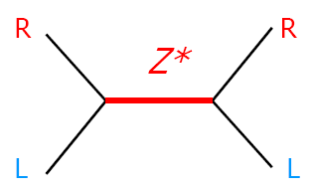 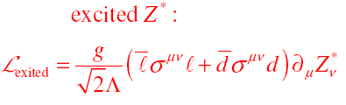

JINR team (Leader M.V.Chizhov) together with ATLAS team from St.Petersburg INR (Leader O.Fedin) within Lepton+X Exotics WG have carried out research on general topic “Search on inclusively produced chiral Z* bosons via their decay into lepton-antilepton pairs”. The obtained data is collected at special Twiki page <https://twiki.cern.ch/twiki/bin/view/AtlasProtected/ZstarEleEle>. In general, the Z* analysis is very similar to the Z’ analysis. However, the peculiar features of the excited bosons result in many differences in comparison with the Z’ results (**Figure below**). This will help to distinguish them an ambiguously from the other neutral resonances with different spins.

 

Experimental searches for these heavy excited bosons with ATLAS detector in the first period of the LHC data analysis were based on proton-proton collision energies of 7 (8) TeV and integrated luminosity of 5(20) fb-1, respectively. The results of these studies were the new upper limits for the cross sections and the masses of the new bosons. The observed mass limits Z*(W*) are 2.85 (3.21) TeV.

Prospects for further Z*, W* searches related, are based primarily on the plans to increase the energy of the proton-proton collisions at the LHC to 13-14 TeV and increase the luminosity of proton beams. Expected number of events with Z*, W* increases proportionally integrated luminosity of the collider, and for large masses of the new bosons significantly increases with the energy of the colliding beams.

The **figure below** shows the dependence of the integrated luminosity necessary for detection (left) or exclusion (right) with a confidence level of 95% of the Z* boson depending on its mass for pp-collisions energy of 13 TeV.

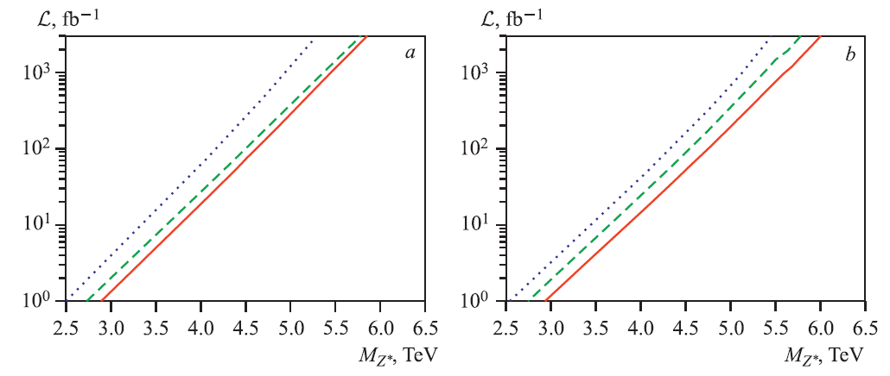

*The integrated luminosity of the proton-proton collisions with energy 13 TeV required for detection (left) or exclusion of the existence (right) of the boson Z * depending on the mass of the latter.*

It should be noted that the increase in energy collision greatly increases the potential for the search of the new physics. For instance, for the pp-collisions with energy of 14 TeV the integrated luminosity smaller than 1fb-1 is required to improve the existing restrictions on the Z* mass, while the analysis of 100 fb-1 data will test the hypothesis of Z* existence up to it mass of 4.5 TeV.

Last 3 years the JINR team continued searches for the Z* boson. Then the search will start for charged chiral W* boson, produced inclusively and decaying into electron-neutrino pair (pp→W*→μν). Due to the missing neutrino energy this analysis seems more complicated.

JINR team holds leading positions in this analysis direction and attracts for cooperation the others ATLAS members. The leaders of the research (M.V.Chizhov and G.Dvali) have recently showed a deep connection between introduced chiral bosons and fresh ideas beyond the SM, such as SUSY and physics of extra dimensions.

Therefore, during 2020 – 2022 JINR team continues the search for the excited bosons not only in the dilepton channels, but also in the dijets final states as well as in associated production with the heavy quarks [M.V. Chizhov, V.A. Bednyakov, J.A. Budagov, Phys. Atom. Nuclei 75 (2012) 90; ATLAS Collaboration, Phys. Rev. D 91, 052007 (2015); M.V. Chizhov, V.A. Bednyakov, Phys. Atom. Nucl. 79 (2016) 721 ]. To prepare for the full Run-II, new Monte-Carlo simulations of productions of the excited bosons should be done in the ATLAS software framework for different channels. This task is a direct responsibility of our Institute. JINR group plans to continue also the data analysis in the muon channel.

**Mixing and mass of Z’ bosons from resonant di-boson searches**

Neutral vector bosons Z are among the best motivated scenarios of physics beyond the Standard Model (SM). Many new physics models beyond the SM, including superstring and left-right-symmetric models, predict the existence of such bosons. They might actually be light enough to be accessible at current and/or future colliders. The search for such neutral Z’ gauge bosons is an important aspect of the experimental physics program of present and future high-energy colliders.

Depending on the considered theoretical model, Z’ masses of the order of 4.5 TeV [3,4] and Z-Z’ mixing angles at the level of 10−3 are already excluded. These constraints come from the very high-precision Z pole experiments at LEP and the Stanford Linear Collider (SLC), including measurements from the Z line shape, from the leptonic branching ratios (normalized to the total hadronic Z decay width) as well as from leptonic forward-backward asymmetries. While these experiments were virtually blind to Z’ bosons with negligible Z-Z’ mixing, precision measurements at lower and higher energies (away from the Z pole) attainable at TRISTAN and LEP2, respectively, were able to probe the Z’ exchange amplitude via its interference with the photon and the SM Z boson. However, as was shown, at the LHC at nominal collider energy of √s = 14 TeV and integrated luminosity of Lint ≈ 100 fb−1 a high potential exists to improve significantly on the current limits on the Z-Z’ mixing angle in the di-boson channel: pp → (Z2 → W+ W-) + X.

In contrast to the Drell-Yan (DY) process pp → Z’ → l+ l− + X, with l = e, μ, the di-boson process is not the principal discovery channel, but can help to understand the origin of new gauge bosons.

The JINR team results are:

1. Set limits on W-W’ mixing angle in the WZ-bosons production processes in Run-I/II

2. Set limits on Z-Z’ mixing angle in the di-boson production processes in Run-II

3. Perform a search for resonant and interference effects of the new calibration bosons, the di-lepton production processes and to set limits on the dynamical parameters and masses in Run-II

**V/H(→ jet-jet)+gamma resonances**

Many proposals for physics beyond the Standard Model (SM) include the prediction of new massive bosons. Examples are Technicolor or little Higgs, as well as extensions to the SM Higgs sector such as including an additional electro-weak singlet scalar. Decay modes of these new bosons include final states with a Z or a W boson and a photon. In addition, decays of heavy spin-1 bosons to the 125 GeV Higgs boson and a photon present an interesting search channel. JINR team participates in a search for massive neutral and charged bosons decaying to a photon and a Z, W, or Higgs boson with subsequent hadronic decay of these bosons. The search uses the Run-II dataset of proton-proton (pp) collision data at a center-of-mass energy √s = 13 TeV.

**Quantum Black Holes**

Models for physics beyond the SM, such as the ADD-model, postulate the existence of extra dimensions which could lead to an energy scale of quantum gravity in the TeV region. And also Randall Sundrum-1 (RS1) model postulates the existence of extra dimensions leading to low gravity at the TeV scale. Quantum black holes are predicted in low-scale gravity models which offer a possible solution to the mass hierarchy problem of the SM by lowering the scale of gravity (MD) from the Planck scale (∼ 1016 TeV) to a value of about 1-10 TeV. Here MD is the multi-dimensional Planck scale. The multi-dimensional paradigm has been developed into models such as that proposed by Arkani-Hamed, Dimopoulous and Dvali (ADD-model). In models with large extra spatial dimensions, like the ADD model, only the gravitational field is allowed to penetrate the n extra spatial dimensions, while all the SM fields are localized in the usual four-dimensional space-time. The model used in this analysis includes the following features. QBHs have masses above MD and have spin=0. The production and decay needs to conserve total angular momentum, color and electric charge. The QBH decay into two particles final states. In other words, the QBHs show quasi-particle behavior in contrast with semi-classical black holes that decay via Hawking radiation to a large number of particles. In these models baryon and lepton numbers can be violated in the QBH production.

JINR team finalizes analysis using Run-II data and after re-optimizations and some preparation work start to analyze Run-III data.

**JINR in the ATLAS SUSY Working group**

**SUSY related charged Higgs search (complex final states)**

JINR has very strongly motivated plans to continue study of discover possibility of charged Higgs boson from MSSM. To prove SUSY discovery one coherently has to find as many SUSY particles as possible, and the charged Higgs boson is one of the main “player” of SUSY. This search will be carried out via charged Higgs boson decay into SUSY final states, charginos and neutralinos. Such final states allow one to search for and discovery the charged Higgs boson when all other his decay channels into ordinary SM particles (non-SUSY) are forbidden. This SUSY decay channel assumes rather large mass of this Higgs boson (large than 250 GeV/c2), where associate charged Higgs and top quark production dominates. All neutralino-chargino Higgs decay channels are considered, where one can find in the final state three charged leptons, two neutral stable invisible neutralinos and some neutrinos.

Preliminary study has shown good prospects of the selected process for discovery of the charged Higgs boson predicted for rather wide parameter space of tan β and mH±. Nevertheless it is possible only for well defined values of the other important MSSM parameters *µ* and *M2*. Therefore, JINR team plans first to study the 4-dimension MSSM parameter space to select the best search strategy on the basis of simulated samples generated for benchmark SUSY points by the ATLAS Higgs WG. First real low luminosity ATLAS data will be used for real background determination (including SUSY backgrounds), later with increase of data first signal search are scheduled (Leader A.P.Cheplakov, F.Ahmadov, A.A.Soloshenko).

JINR work and plans on charged Higgs search are approved by HSG5 WG and were discussed at two Workshops of the WG in Dubna.

In general, a study of SUSY with ATLAS detector, discovery of SUSY and coherent (SUSY) solution of the dark matter problem are between the primary goals of JINR participation in the ATLAS experiment.

**JINR in the ATLAS software development**

**Events indexing**

The EventIndex is a complete catalog of all ATLAS events, keeping the references to all files that contain a given event at any processing stage. It takes event information from various data sources, such as CERN and Grid sites. It is also checks data for corruption and consistency, provides information about overlap of events or datasets by different trigger chains as well as fast data overview. JINR team during last 3 years participated in development and support of the control system of the data indexing on the GRID servers, system parameters and production monitoring and as well as full support of the EventIdex system.

**TDAQ system**

JINR team participates in support of components of the real time TDAQ system, development of the operational monitoring systems and networks monitoring.

**Human Resources**

A total number of 32 (29 FTE) personnel in the JINR group participated in the ATLAS Physics program including 6 professors, 12 postdocs and 14 young scientists and students, 27 employees are involved in the work on the ATLAS detector upgrade (14.4 FTE). The whole Team provides 43.4 FTE.

Besides the participation in the analysis itself members of the ATLAS-JINR Team were also playing managerial roles in the Collaboration. In the recent period we were taking responsibilities of conveners and sub-conveners of the ATLAS Working Groups (WG) as well as technical contacts persons with others Working Groups, such as Standard Model WG, B-Physics sub-group, Trigger Performance etc.

Major part of them are engaged in the project for many years. They have well-recognized reputation within the Collaboration and beyond, solid background and necessary skills to fulfill all our obligations.

**Maintenance and operation responsibilities**

According to the decision of the ATLAS Management the following procedure for sharing of ATLAS Operation Tasks is established for 2010 and thereafter:

1. Operation Tasks (OTs) are regrouped into three categories:

– Class 1: ACR shifts - Central and Detector Shifts in ATLAS Control Room at Point-1.

– Class 2: Other shifts - Additional shifts, including shifts in satellite control rooms, computing shifts, remote shifts, on-call shifts.

– Class 3: Expert operation tasks - Operation tasks involving experts on systems, data preparation, computing, software.

2. Institutions are expected to contribute to each of the three classes according to their OT share. As of 2015 Class 1 and Class 2 are combined in OT one can therefore do either. Activities of one class cannot be freely substituted for activities of another class. For example, Class 3 OTs (expert operation tasks) cannot be substituted for Class 1 OTs (ACR shifts) or Class 2 (On-call shifts).

During the 2020-2022 period JINR has successfully secured all requested OTs of Class 1 and 2 providing:

1. 0.56 FTEs with 0.45 FTEs requested in 2020

2. 0.63 FTEs with 0.44 FTEs requested in 2021

3. 1.53 FTEs with 1.13 FTEs requested in 2022

The main task is participation in the ATLAS SLIMOS/TI - Safety shifter and we would like to continue to cover this kind of shifts in that way.

At the beginning of the 2020-2022 period the Class 3 shifts were covered at the level of ~30%.

1. 5.54 FTEs with 7.64 FTEs requested in 2020

2. 7.50 FTEs with 7.60 FTEs requested in 2021

3. 6.93 FTEs with 9.52 FTEs requested in 2022

This coverage was mainly due to “Grid Data Processing & Analysis” and “DAQ/HLT Control & Configuration” and authorship qualification tasks. There are several minor tasks usually provided by JINR Team members in the detector sub-systems

Till the beginning of the 2017 the lack of the FTEs in this Class shifts from JINR was not a cause for concern. But the experience over the past years has shown that there is a shortage of person power in the so-called operation and service areas. It was decided to implement so-called Institutional Commitments: when ATLAS institutions commit to carry out certain tasks on a long-term basis and to provide service or certain deliverables to detector operation or to the other activity areas (Trigger, Data Preparation, Computing & Software, and Physics). The ATLAS-JINR Team management introduced special requirements to secure Class-3 shifts quota. First, each postdoc and young scientist of our physics analysis team should take responsibility for at least 0.25 FTEs. It was done by participation in the TileCal software development, B-physics trigger efficiency calculation, optimization and its software maintenance. Also in 2018 on the base of JINR the team for the “Event Indexing” task. Initially there were four participants working partially and they provided ~1.5 FTEs, and since 2019 one more participant with 1 FTE has joined this team. In addition this year the team of four participants has got ATLAS software development grant and we expect that they will participate at the level of ~2 FTEs.

**List of publications**

In this section the complete list of publications with significant contribution of the ATLAS-JINR Team members is presented for the period of 2020 – 2022.

**Journal publications**

1. S. Turchikhin et al., ATLAS data quality operations and performance for 2015-2018 data-taking, [JINST 15 (2020) P04003](https://iopscience.iop.org/article/10.1088/1748-0221/15/04/P04003)

2. E. Khramov et al., Search for heavy resonances decaying into a photon and a hadronically decaying Higgs boson in pp collisions at √s=13 TeV with the ATLAS detector, [Phys. Rev. Lett. 125 (2020) 251802](https://journals.aps.org/prl/abstract/10.1103/PhysRevLett.125.251802)

3. F. Ahmadov et al., Measurements of WH and ZH production in the H→bb decay channel in $pp$ collisions at 13 TeV with the ATLAS detector, [Eur. Phys. J. C 81 (2021) 178](https://link.springer.com/article/10.1140/epjc/s10052-020-08677-2)

4. D. Kharchenko, V. Kruchonak, V. Elkin et al., Performance of the ATLAS RPC detector and Level-1 muon barrel trigger at √s=13 TeV, [JINST 16 (2021) P07029](https://iopscience.iop.org/article/10.1088/1748-0221/16/07/P07029)

5. I. Eletskikh et al., AtlFast3: the next generation of fast simulation in ATLAS, [Comput Softw Big Sci 6, 7 (2022)](https://link.springer.com/content/pdf/10.1007/s41781-021-00079-7.pdf)

6. T. Lyubushkina, S. Turchikhin et al., Study of Bc+ → J/ψ Ds+ and Bc+ → J/ψ Ds*+ decays in $pp$ collisions at √s=13 TeV with the ATLAS detector, [JHEP 08 (2022) 087](https://link.springer.com/article/10.1007/JHEP08(2022)087)

7. T. Lyubushkina, S. Turchikhin et al., Performance of the ATLAS muon triggers in Run 2, [JINST 15 (2020) P09015](https://iopscience.iop.org/article/10.1088/1748-0221/15/09/P09015)

8. S. Turchkhin et al., Measurements of the production cross-section for a Z boson in association with b-jets in proton-proton collisions at √s=13 TeV with the ATLAS detector, [JHEP 07 (2020) 44](https://link.springer.com/article/10.1007/JHEP07(2020)044?wt_mc=Internal.Event.1.SEM.ArticleAuthorIncrementalIssue&utm_source=ArticleAuthorIncrementalIssue&utm_medium=email&utm_content=AA_en_06082018&ArticleAuthorIncrementalIssue_20200711)

9. D. Dedovich, A. Gongadze, L. Gongadze, V. Kruchonok, I. Minashvili, R. Sotensky and D. Zavazieva, Bulk Micromegas fabrication at JINR, 2019 JINST **14** T07004

10. E. Cherepanova et al., A search for the decays of stopped long-lived particles at √s=13 TeV with the ATLAS detector, [JHEP 07 (2021) 173](https://link.springer.com/article/10.1007/JHEP07(2021)173)

11. G.I. Lykasov, A.V. Lipatov et al., Novel Heavy-Quark Physics Phenomena, *Prog.Part.Nucl.Phys.* 114 (2020) 103802

12. Lipatov, A. V. and Lykasov, G. I. and Malyshev, M. A. and Turchikhin, S. M., Probing the proton structure with associated vector boson and heavy flavor jet production at the LHC, *Phys.Rev.D* 106 (2022) 5, 054017

13. Lipatov, A. V. and Lykasov, G. I. and Malyshev, M. A., Toward the global fit of the TMD gluon density in the proton from the LHC data, *Phys.Rev.D* 107 (2023) 1, 014022

14. Prokhorov, A. A. and Lipatov, A. V. et al., Revisiting the production of J/ψ pairs at the LHC, *Eur.Phys.J.C* 80 (2020) 11, 1046

15. Baranov, S. P., Lipatov, A. V., Prokhorov, A. A., Charm fragmentation and associated J/ψ +Z/W± production at the LHC

16. Baranov, S. P., Lipatov, A. V., Prokhorov, A. A., Role of initial gluon emission in double J/ψ production at central rapidities, *Phys.Rev.D* 106 (2022) 3, 034020

17. A.A. Pankov et al., Updated constraints on Z' and W' bosons decaying into bosonic and leptonic final states using the run 2 ATLAS data, *Phys.Rev.D* 103 (2021) 5, 053009

18. Serenkova, I. A., Pankov, A. A., Bednyakov, V. A., Improved Constraints on the Heavy Gauge Bosons Decaying to Pairs of Electroweak Bosons by Using the Expected Run 3 Data and HL-LHC Options, *Nonlin.Phenom.Complex Syst.* 25 (2022) 4, 318-325

19. Yu. A. Koultchitski, P. Tsiareshka, N.A. Rusakovich, E. Plotnikova et al., Two-particle Bose-Einstein correlations in pp collisions at √s=13 TeV measured with the ATLAS detector at the LHC, [Eur. Phys. J. C 82 (2022) 608](https://link.springer.com/article/10.1140/epjc/s10052-022-10472-0)

**Other publications:**

1. F. Ahmadov et al., Measurements of WH and ZH production in the H→bb decay channel in pp collisions at 13 TeV with the ATLAS detector, ATLAS-CONF-2020-006

2. E. Khramov et al., Search for high-mass Wγ and Zγ resonances using 139 fb-1 of pp collisions at √s = 13 TeV with the ATLAS detector, ATLAS-CONF-2021-041

3. T. Lyubushkina, S. Turchikhin et al., Study of the Bc+ → J/ψ Ds+ and Bc+ → J/ψ Ds*+ decays in pp collisions at $\sqrt{s} =13$ TeV with the ATLAS detector, ATLAS-CONF-2021-046

4. I. Yeletskikh, A. Vasyukov et al., Observation of an excess of di-charmonium events in the four-muon final state with the ATLAS detector, ATLAS-CONF-2022-040

**List of conferences and talks**

In this section the full list of conferences where members of the ATLAS-JINR Team took part (17 talks at 15 conferences):

1. INSTR-2020

* I. Minashvili: Construction and geometrical precision assessment of the Micromegas detectors for the ATLAS New Small Wheel upgrade

2. PHENO-2020

* T. Lyubushkina: ATLAS results on quarkonia and heavy flavour production (including exotics)

3. Epiphany-2020

* Y. Koultchitski: Soft QCD at ATLAS and CMS

4. ICHEP-2020

* S. Turchkhin: ATLAS studies of Spectroscopy and exotics

5. [MPI@LHC-2021](mailto:MPI@LHC-2021)

* Y. Koultchitski: Minimum Bias & Underlying Event studies at ATLAS: review of measurements and MC tuning

6. QWG-2021

* I. Yeletskikh: Quarkonium production studies in pp collisions at ATLAS

7. LHCP-2021

* M. Demichev: Tests of LM2 MicroMegas Modules on Cosmic stand in Dubna

8. FPCP-2021

* I. Yeletskikh: ATLAS results on exotic heavy hadrons
* I. Yeletskikh: Exotics hadrons at hadronic machines

9. EPS-HEP-2021

* T. Lyubushkina: ATLAS results on charmonium production and Bc production and decays

10. HADRON-2021

* T. Lyubushkina: ATLAS results on charmonium production and Bc production and decays

11. ICNFP-2021

* I. Yeletskikh: ATLAS results on charmonium production, Bc production and decays, and exotic heavy hadrons

12. PANIC-2021

* I. Yeletskikh: ATLAS results on J/psi p resonances in the Λb -> J/ψ p K decays
* S. Turchikhin: ATLAS results on charmonium production and Bc production and decays

13. LC-2021

* S. Turchikhin: ATLAS results on charmonium production and Bc production and decays

14. ICNFP-2022

* I. Yeletskikh: ATLAS results on exotic hadronic resonances

15. LHC Days 2022

* I. Yeletskikh: B-physics in ATLAS and CMS

**Theses**

1. A. Tropina, Study of the associated production of the Higgs boson and top quark at the ATLAS experiment, Bachelor Thesis
2. A. Didenko, Application of machine learning for the analysis of Higgs boson production in association with single top-quark, Master Thesis
3. A. Vasyukov, Study of tetraquarks Zc(4200) in B0 to J/ψKπ decays, Master Thesis
4. M. Manashova, Study of the associated production of the Higgs boson and W- or Z-boson using different Monte-Carlo generators, Master Thesis

**Participating countries, scientific and educational organizations**

|  |  |  |  |  |
| --- | --- | --- | --- | --- |
| **Organization** | **Country** | **City** | **Participants** | **Type**  **of agreement** |
| Foundation ANSL | Armenia | Yerevan | G. Akopyan | Collaborative work |
| IP ANAS | Azerbaijan | Baku | N. Huseynov + 5 | Collaborative work |
| GSTU | Belarus | Gomel | A.A. Pankov + 3  I.A. Serenkova + 1 | Visits exchange |
| GSTU | Belarus | Gomel | A.A. Babich + 1 | Collaborative work |
| GSU | Belarus | Gomel | N.V. Maksimenko | Visits exchange |
| GSU | Belarus | Gomel | V.V. Andreev + 2 | Collaborative work |
| IAP NASB | Belarus | Minsk | R.G. Shulyakovsky + 2 | Visits exchange and collaborative work |
| IP NASB | Belarus | Minsk | Yu.A. Kurochkin + 3 | Visits exchange and collaborative work |
| INP BSU | Belarus | Minsk | A.A. Solin  A.V. Solin  P.M. Starovoitov + 5 | Visits exchange |
| INP BSU | Belarus | Minsk | A.V. Grinevich | Collaborative work |
| JIPNR-Sosny NASB | Belarus | Minsk | V.V. Gilevsky + 2 | Visits exchange and collaborative work |
| SU | Bulgaria | Sofia | M.V. Chizhov | Collaborative work |
| UdeM | Canada | Montreal | C. Leroy | Collaborative work |
| TRIUMF | Canada | Vancouver | L.L. Kurchaninov | Collaborative work |
| CERN | CERN | Geneva | M. Vincter  A. Hoecker  K. Jacobs | Cooperation agreement |
| LPC | France | Clermont-Ferrand | F. Vasey | Collaborative work |
| LAL | France | Orsay | D. Fournier | Collaborative work |
| HEPI-TSU | Georgia | Tbilisi | T. Djobava + 3 | Cooperation agreement |
| INFN | Italy | Pisa | T. Del Prete | Collaborative work |
| NIKHEF | Netherlands | Amsterdam | H. Van Der Graaf | Collaborative work |
| ITEP | Russia | Moscow | I. Tsukerman | Collaborative work |
| LPI RAS | Russia | Moscow | A. Snesarev + 1 | Collaborative work |
| MSU | Russia | Moscow | L. Smirnova | Collaborative work |
| IHEP | Russia | Protvino | S. Denisov  A. Zaytsev | Collaborative work |
| NOSU | Russia | Vladikavkaz | I. Tvauri | Collaborative work |
| CU | Slovakia | Bratislava | A. Dubnickova  S. Tokar | Collaborative work |
| IP SAS | Slovakia | Bratislava | S. Dubnicka + 3 | Collaborative work |
| IFAE | Spain | Barcelona | M. Cavalli-Sforza | Collaborative work |
| ANL | USA | Lemont, IL | L. Price | Cooperation agreement |
| SSU | Uzbekistan | Samarkand | A. Artikov  U. Salikhbaev | Collaborative work |

**Manpower (actual at the time of reporting)**

|  |  |  |  |
| --- | --- | --- | --- |
| **No.** | **Personnel category** | **JINR staff,**  **FTE amount** | **JINR associated personnel,**  **FTE amount** |
| 1. | research scientists | 35.8 | 1 |
| 2. | engineers | 6.3 |  |
| 3. | specialists | 1.3 |  |
|  | **Total:** | **43,4** | **1** |

**Expenditures for the Project** **PHYSICS RESEARCH WITH ATLAS DETECTOR AT THE LHC RUN-III (JINR PARTICIPATION)** (in kUSD)

|  |  |  |  |  |  |
| --- | --- | --- | --- | --- | --- |
|  | Expenditure items | Full cost  (2020-2022) | 1st year  2020 | 2nd year  2021 | 3rd year  2022 |
| 1. | Direct expenses for the Project:  design bureau, ATLAS detector maintenance, payments for agreement-based research | 829.4 | 387.2 | 348.1 | 94.1 |
| 2. | JINR obligations on participation in the detector upgrade (Phase 1 MoU) | 300.0 | 20 | 30 | 30 |
| 3. | Travel allowance: | 566.8 | 154.3 | 194.2 | 218.3 |
|  | **Total direct expenses** | **1476.2** | **561.5** | **572.3** | **342.4** |

**Theme leader**

**/ V. Bednyakov /**

**" " 202_г.**

**Project /LRIP subproject leader (project code)**

**/ E. Khramov_/**

**" " 202_г.**

**Project / LRIP subproject leader (project code)**

**/ A. Cheplakov /**

**" " 202_г.**

**Laboratory Economist**

**/__________ _/**

**" " 202_ г.**